1) Move Zeroes (#283)
Given an integer array nums, move all 0's to the end of it while maintaining the relative order of the non-zero elements.
Note that you must do this in-place without making a copy of the array.
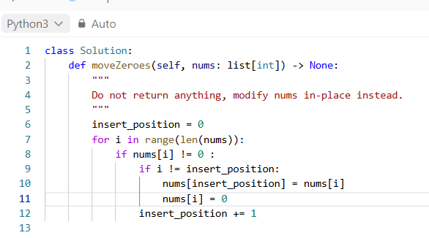
class Solution:
- This defines a Python class called Solution.
- LeetCode expects your solution to be written inside this class. Its testing system creates an instance and calls the method.
def moveZeroes(self, nums: list[int]) -> None:
- This defines the method that solves the problem.
- self refers to the current instance of the Solution class.
- nums is the input array, such as [0, 1, 0, 3, 12].
- list[int] indicates that nums is a list of integers.
- -> None indicates that the method does not return a value.
insert_position = 0
- This is the most important variable in the algorithm.
- insert_position tracks the index where the next non-zero element should be placed.
- Initially, it is 0, because the first non-zero number should occupy index 0.
for i in range(len(nums)):
- This loop visits every index in the array.
if nums[i] != 0:
- This checks whether the current element is non-zero.
- If the element is 0, we skip it and continue scanning.
- If it is non-zero, we need to ensure that it occupies the correct position near the beginning of the array.
if i != insert_position:
- This checks whether the current non-zero element is already in the correct position.
nums[insert_position] = nums[i]
- This copies the current non-zero value into the next available position.
nums[i] = 0
- This replaces the original position of the moved element with 0.
insert_position += 1
- This increases the insertion pointer by one.

TRACING
nums = [0, 1, 0, 3, 12]
insert_position = 0
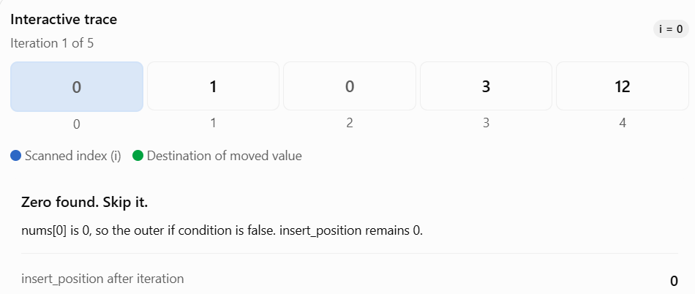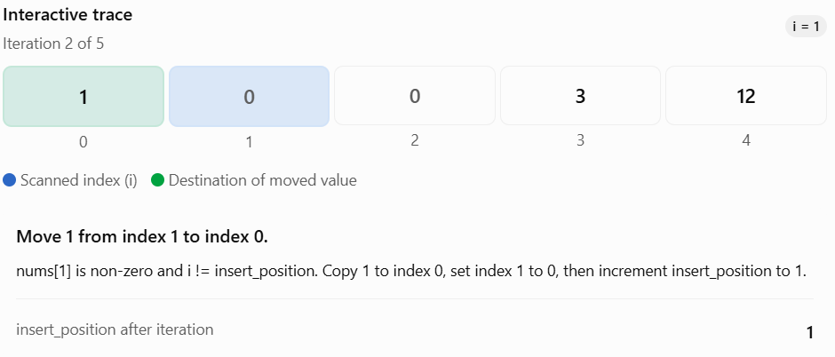

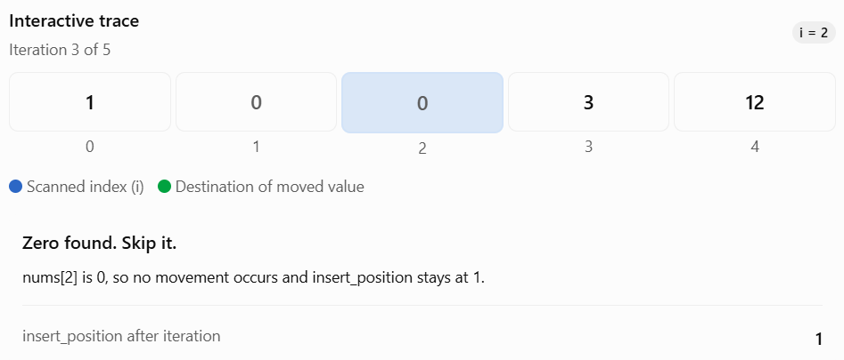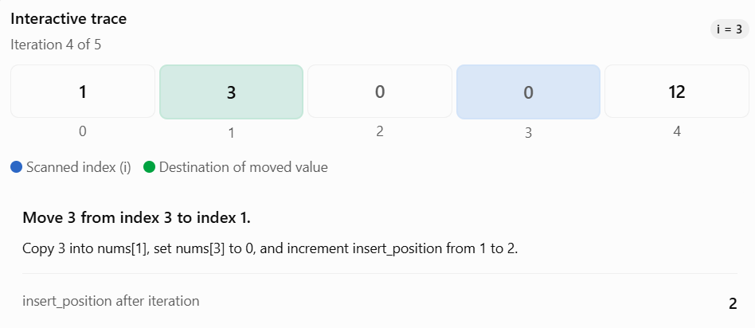
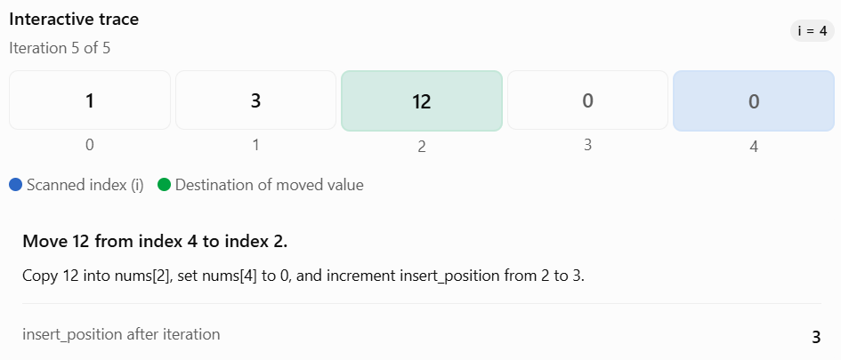
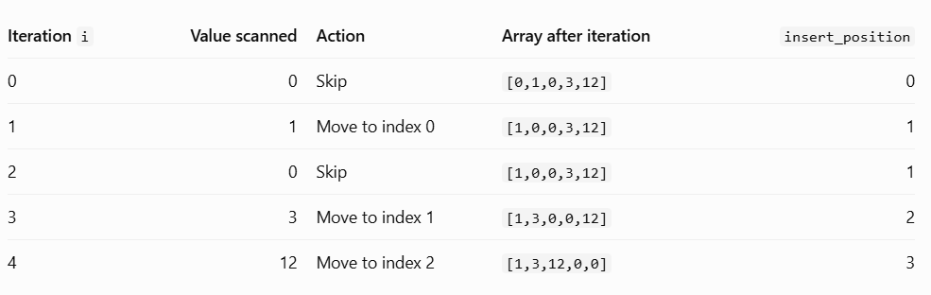

2) Majority Element (#169)
Given an array nums of size n, return the majority element.
The majority element is the element that appears more than ⌊n / 2⌋ times. You may assume that the majority element always exists in the array.
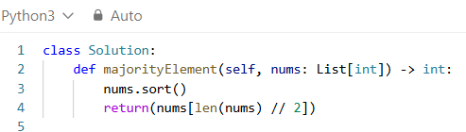

nums.sort()
- This sorts the array in ascending order.
return(nums[len(nums) // 2])
Step 1: len(nums)
- Returns the number of elements in the array.
- nums = [1, 1, 1, 2, 2, 2, 2]len(nums) = 7
Step 2: len(nums) // 2
- The // operator performs floor division.
- 7 // 2 = 3
- This gives the middle index.
- Remember that Python uses zero-based indexing.
Step 3: nums[len(nums) // 2]
- This retrieves the element at index 3.
- nums[3] = 2
Step 4: return
- Returns 2 as the answer.
- You can also write the same line more simply:
- return nums[len(nums) // 2]
- The parentheses around the returned expression are optional.
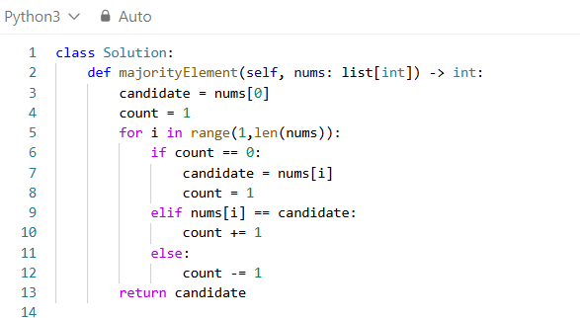

candidate = nums[0]
- We select the first element of the array as our initial candidate.
count = 1
- We initialize the count to 1.
- Why 1 and not 0?
- Because we have already selected nums[0] as our candidate, and that element contributes one vote.
for i in range(1,len(nums)):
- This loop visits every element starting from index 1.
if count == 0:
- This checks whether the current candidate has lost all its unmatched votes.
candidate = nums[i]
- When count is zero, we select the current element as the new candidate.
count = 1
- We initialize the new candidate's count to 1.
- Why 1?
- Because the current element itself gives one vote to the newly selected candidate.
elif nums[i] == candidate:
- This checks whether the current number matches our candidate.
count += 1
- This increases the candidate's count by one.
else: count -= 1
- This executes when the current element differs from the candidate and the count was not zero.
return candidate
- After processing the entire array, we return the surviving candidate.
TRACING
nums = [2, 2, 1, 1, 1, 2, 2]
Initial values:
- candidate = nums[0] # 2
- count = 1
- The loop starts at i = 1.
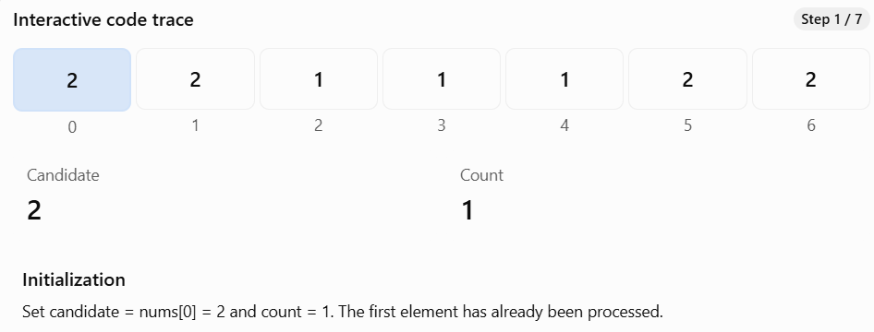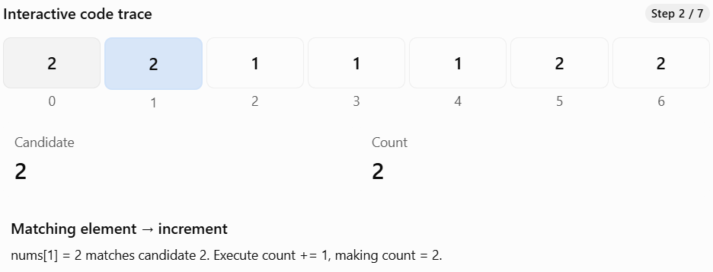
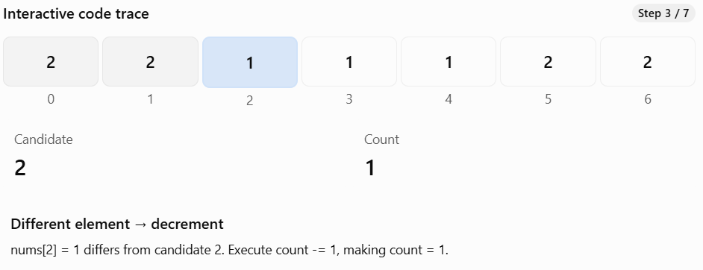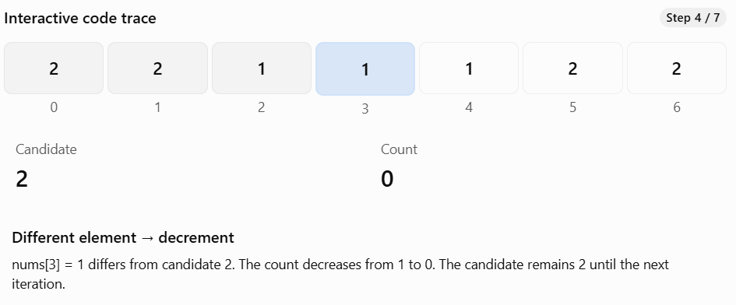
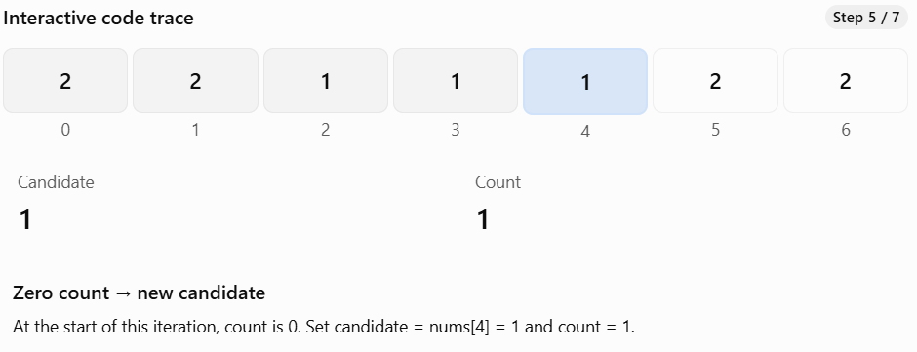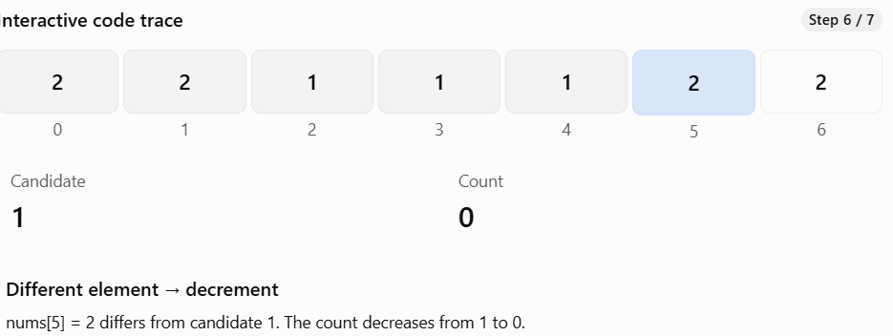
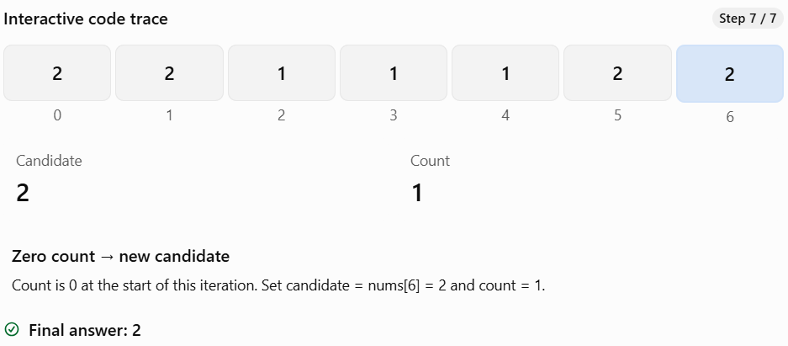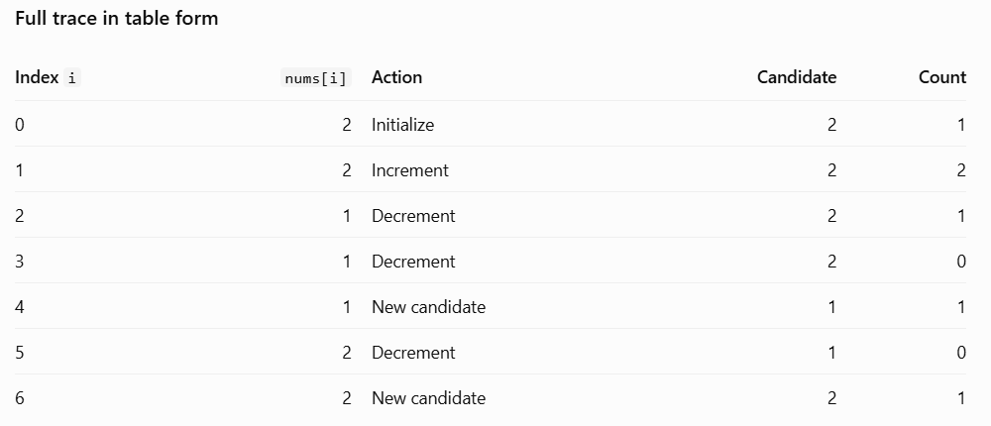
- Pattern: Boyer–Moore Voting Algorithm.
- Core idea: Cancel votes from different elements.
- Candidate: The element currently being considered as the majority.
- Count: The unmatched voting balance, not the actual frequency.
- When count becomes zero: Select a new candidate.
- Complexity: O(n) time and O(1) space.
- Critical condition: A majority element must be guaranteed; otherwise verify the candidate with a second pass.

3) Product of Array Except Self (#238)
Given an integer array nums, return an array answer such that answer[i] is equal to the product of all the elements of nums except nums[i].
The product of any prefix or suffix of nums is guaranteed to fit in a 32-bit integer.
You must write an algorithm that runs in O(n) time and without using the division operation.
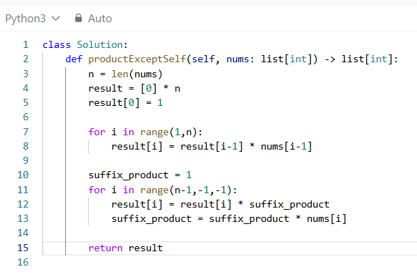
def productExceptSelf(nums: list[int]) -> list[int]:
- This defines a function named productExceptSelf.
- Input: a list of integers.
- Output: a new list of integers.
n = len(nums)
- Stores the number of elements in the array.
result = [0] * n
- Creates a new list containing n zeroes.
- result = [0, 0, 0, 0]
result[0] = 1
- This is an important initialization
- The first element has no elements to its left.
- Mathematically, the product of an empty collection is defined as 1.
- Why not 0?
- Because 1 is the multiplicative identity:
- If we used 0, every multiplication involving it would become zero.
for i in range(1, n):
- This loop calculates the product of all elements to the left of each index.
- We start at index 1 because result[0] is already initialized.
result[i] = result[i - 1] * nums[i - 1]
- This is the most important statement in the first loop.
- Let's break it into three parts:
- result[i - 1] is the product of everything before the previous index.
- nums[i - 1] is the value at the previous index.
- Multiplying them gives the product of everything before the current index.
suffix_product = 1
- This variable tracks the product of elements to the right of the current index.
- We initialize it to 1 because the last element has nothing to its right.
- Unlike prefix products, we do not create a separate suffix array.
for i in range(n - 1, -1, -1):
- This loop moves backwards through the array.
- Python's range() can accept three arguments:
- range(start, stop, step)
- start = n - 1 means the last index.
- stop = -1 means stop before reaching -1.
- step = -1 means move backwards by one index.
result[i] = result[i] * suffix_product
- At this point:
- result[i] contains the product of elements to the left.
- suffix_product contains the product of elements to the right.
- Multiplying them gives the product of every element except the current one.
suffix_product = suffix_product * nums[i]
- After calculating the answer for index i, we include nums[i] in the suffix product so it can be used for the next index to the left.
- Why do we update the suffix after multiplying result[i]?
- Because we must exclude nums[i] from its own answer.
- If we update the suffix first, we would accidentally include the current element.
return result
- Returns the completed output array.
TRACING
nums = [1, 2, 3, 4]
n = 4
result = [0, 0, 0, 0]
result[0] = 1
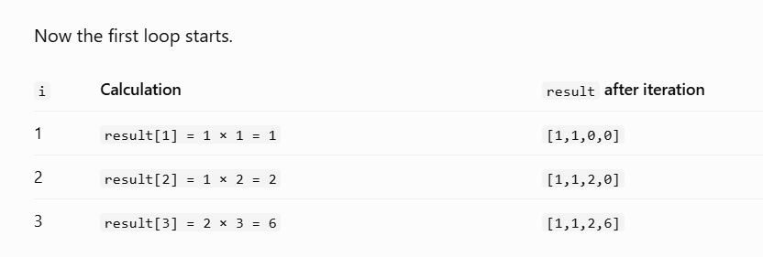
- At the end of the first pass:
- result = [1, 1, 2, 6]
- Each position now contains the product of everything strictly to its left.
Now we have:
nums = [1, 2, 3, 4]
result = [1, 1, 2, 6]
suffix_product = 1
The loop runs backwards: i = 3, 2, 1, 0.
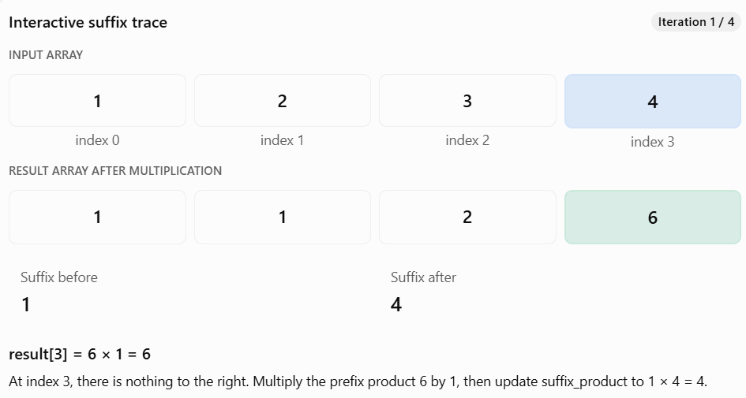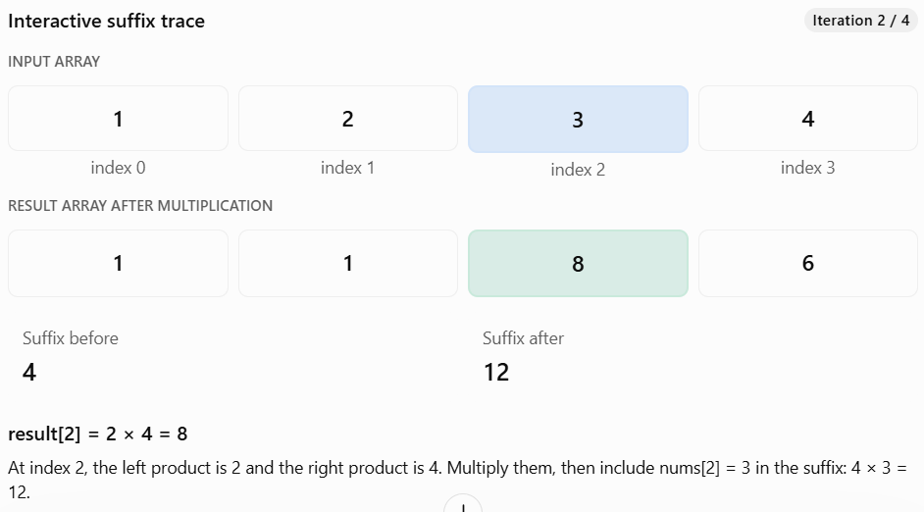
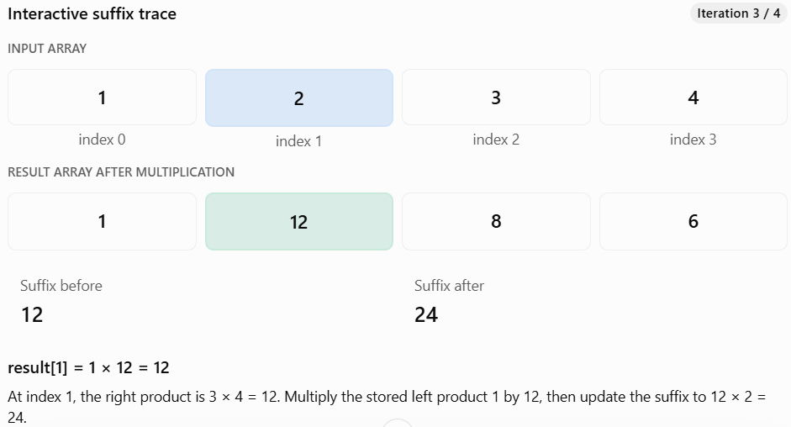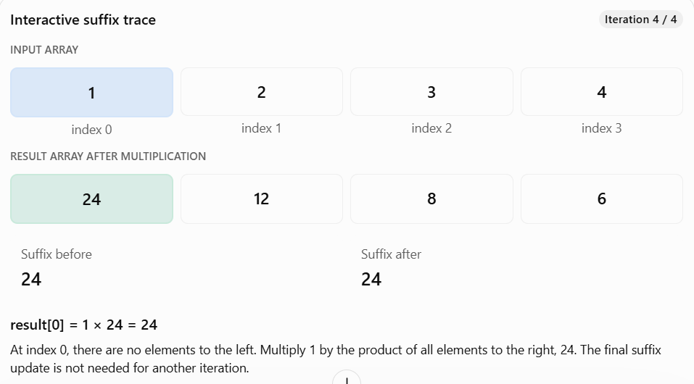
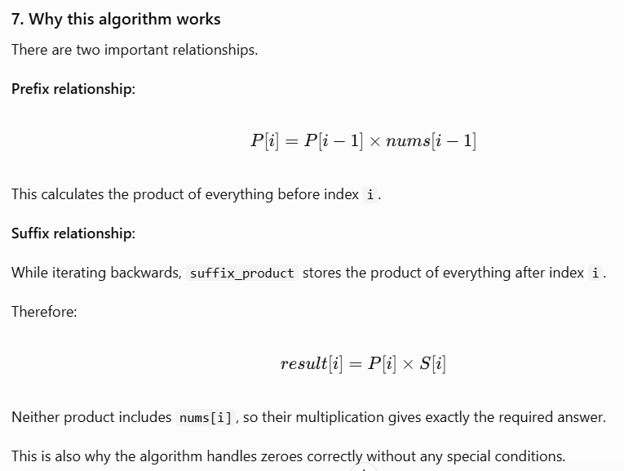

4) Best Time to Buy and Sell Stock II (#122)
You are given an integer array prices where prices[i] is the price of a given stock on the ith day.
On each day, you may decide to buy and/or sell the stock. You can only hold at most one share of the stock at any time. However, you can sell and buy the stock multiple times on the same day, ensuring you never hold more than one share of the stock.
Find and return the maximum profit you can achieve.

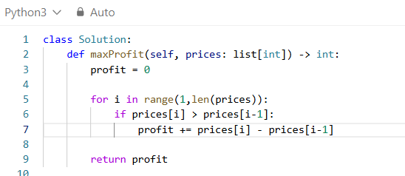
This uses a Greedy Algorithm: whenever the stock price increases from one day to the next, we add that increase to our profit.
profit = 0
- We initialize the total profit to zero because we haven't made any profitable transactions yet.
for i in range(1, len(prices)):
- We start from index 1 because we need to compare the current day's price with the previous day's price.
- For six elements, i takes the values 1, 2, 3, 4, 5.
if prices[i] > prices[i - 1]:
- We check whether the stock price increased compared with the previous day.
- If it increased, there is a positive profit opportunity.
- If it decreased or remained unchanged, we don't add anything
profit += prices[i] - prices[i - 1]
- This calculates the increase and adds it to our accumulated profit.
return profit
- Returns the maximum profit accumulated across all profitable price increases.
TRACING
prices = [7, 1, 5, 3, 6, 4]
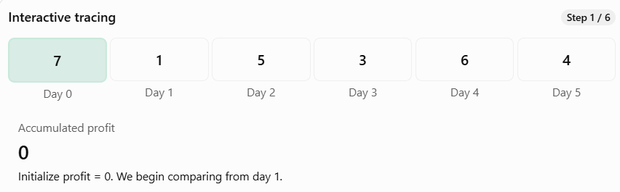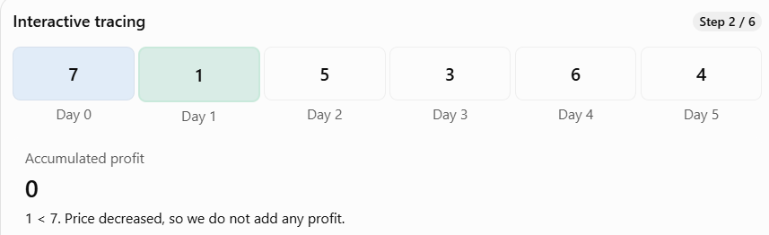
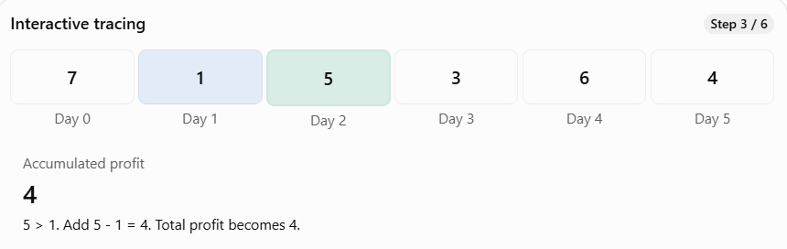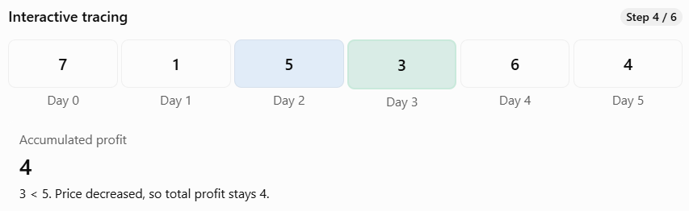
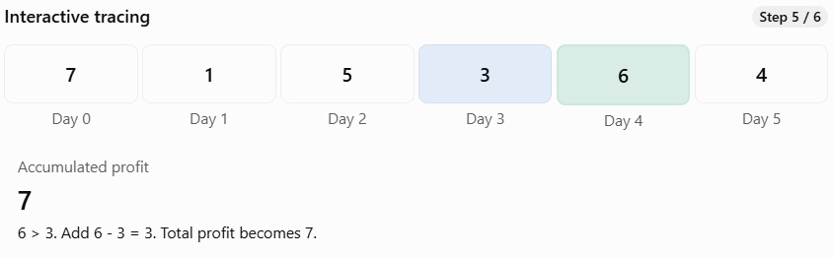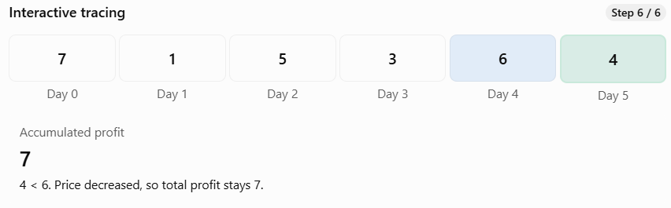
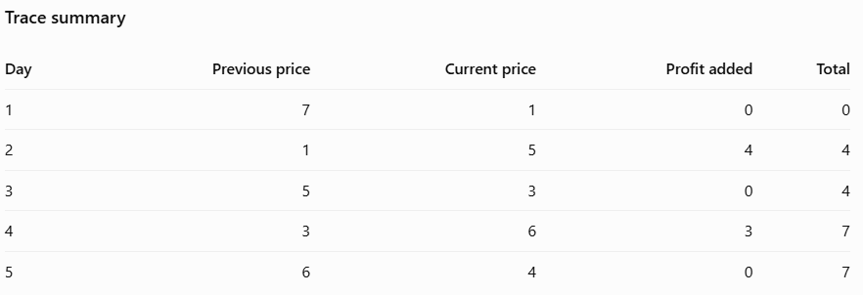

5) First Missing Positive (#41)
Given an unsorted integer array nums. Return the smallest positive integer that is not present in nums.
You must implement an algorithm that runs in O(n) time and uses O(1) auxiliary space.
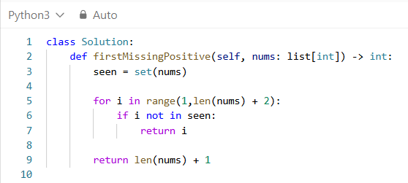
class Solution:
- Defines the class expected by LeetCode.
def firstMissingPositive(self, nums: list[int]) -> int:
- nums is the input integer array.
- list[int] indicates that the list contains integers.
- int indicates that the function returns an integer.
seen = set(nums)
- This converts the input list into a set.
- For example: nums = [3, 4, -1, 1]
- seen = {1, 3, 4, -1}
- A set has two important properties:
- It stores unique elements.
- It supports fast membership checking.
- For example:
- 1 in seen # True
- 2 in seen # False
- 3 in seen # True
- If the input contains duplicates:
- nums = [1, 1, 2, 2, 3]
- The set becomes:
- seen = {1, 2, 3}
- Duplicates are automatically removed.
- Also, the order in which a set displays its elements is not important for this algorithm.
for i in range(1, len(nums) + 2):
- This is a particularly important line.
- Let's say: nums = [3, 4, -1, 1]
- Then: len(nums) = 4
- So the loop becomes:
- for i in range(1, 6):
- In Python, the ending value of range() is excluded.
- Therefore, the loop checks:
- 1, 2, 3, 4, 5
- Why len(nums) + 2?
- If an array contains n elements, the smallest missing positive integer must be between 1 and n + 1.
- For example:
- nums = [1, 2, 3, 4]
- All four positive integers are present.
- The missing positive is: 5
- So we need to check through n + 1.
- Since Python's range() excludes its stopping value, we use:
- range(1, n + 2)
- This includes n + 1.
if i not in seen:
- This checks whether the current positive integer is absent from the set.
- For example:
- seen = {1, 3, 4, -1}
- When: i = 1
- The condition is: 1 not in seen # False
- So we continue.
- When: i = 2
- The condition becomes: 2 not in seen # True
- We have found the smallest missing positive integer.
return i
- Returns the first positive integer that is missing.
- Because we check the numbers in increasing order, the first missing number is guaranteed to be the smallest.
- For our example:
- return 2
return len(nums) + 1
- In your current implementation, this line is unreachable.
- Why?
- Because the loop already checks every number from 1 through n + 1, and at least one of those numbers must be missing.
- Therefore, the function will always return from inside the loop.
TRACING
nums = [3, 4, -1, 1]
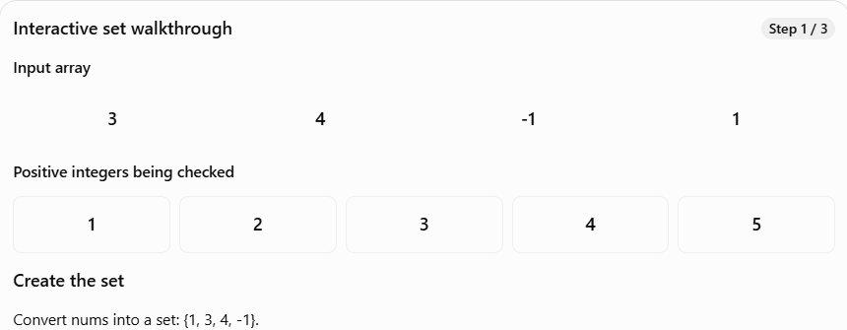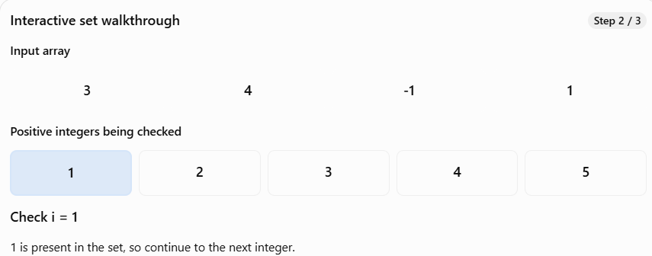
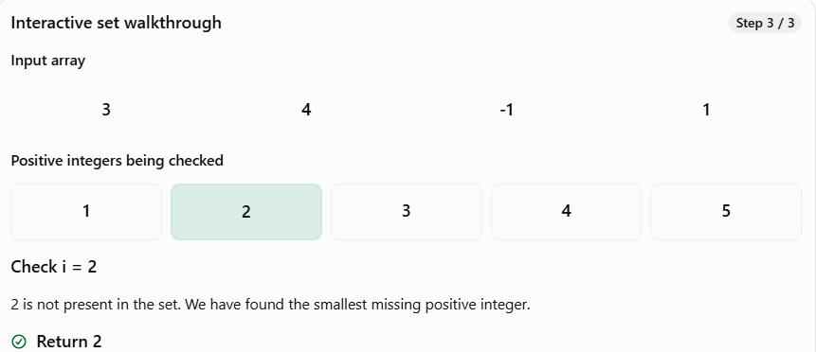

6) Is Subsequence (392)
Given two strings s and t, return true if s is a subsequence of t, or false otherwise.
A subsequence of a string is a new string that is formed from the original string by deleting some (can be none) of the characters without disturbing the relative positions of the remaining characters. (i.e., "ace" is a subsequence of "abcde" while "aec" is not).
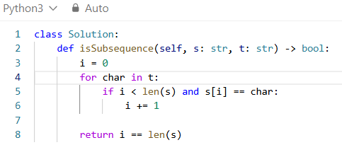
i = 0
- This pointer represents the index of the next character we need to match in s.
- Initially, i = 0, meaning we're looking for s[0].
- For s = "abc", that's 'a'.
for char in t:
- We go through every character in t, from left to right.
- For "ahbgdc", the loop visits:
- a → h → b → g → d → c
if i < len(s) and s[i] == char:
- This checks two things:
- i < len(s) — we still have characters in s to match.
- s[i] == char — the current character in t matches the next required character in s.
- We use i < len(s) to avoid an index-out-of-range error once all characters have been matched.
i += 1
- When we find a matching character, move to the next character of s.
- If the characters don't match, we simply continue searching through t.
return i == len(s)
- If i reaches the length of s, every character in s has been matched in the correct order.
- Therefore, return True. Otherwise, return False.

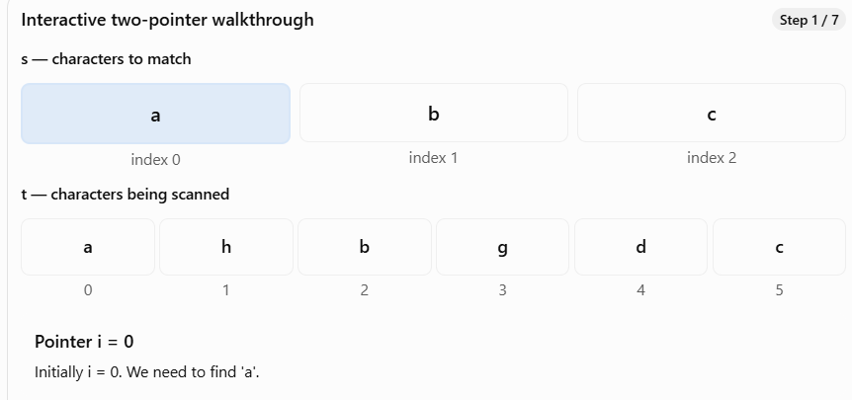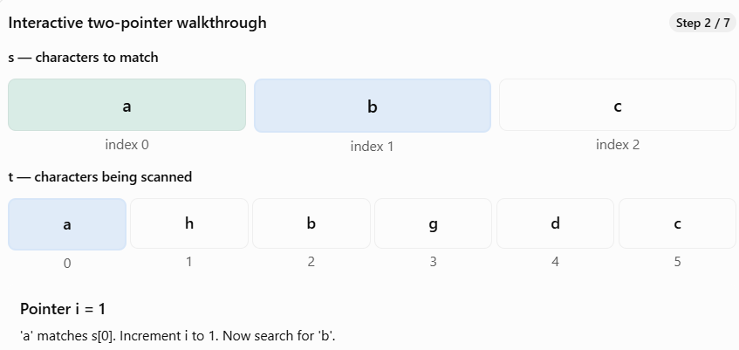
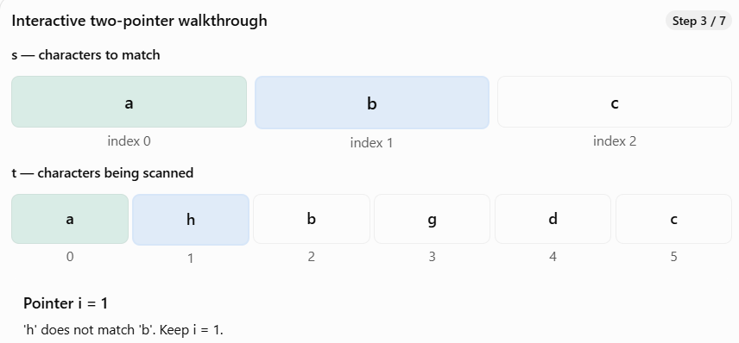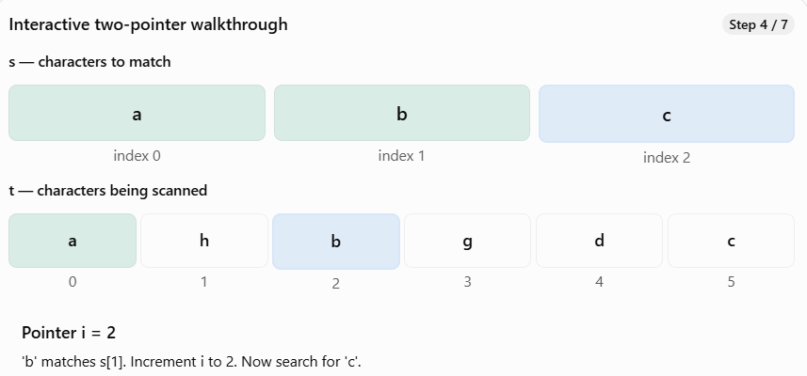
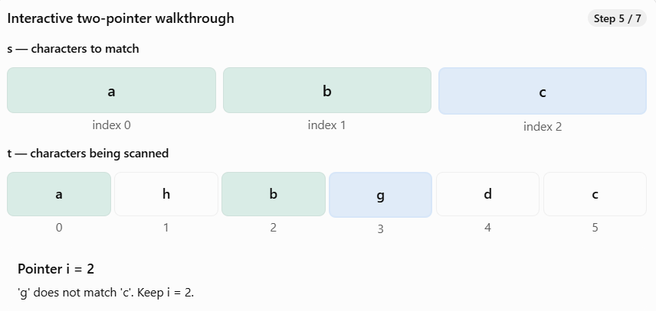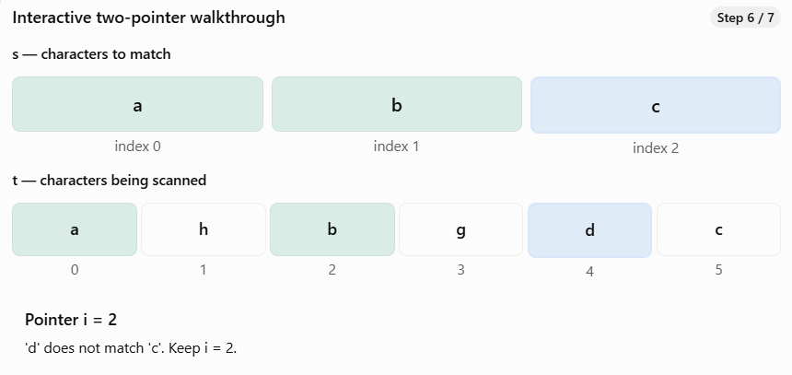
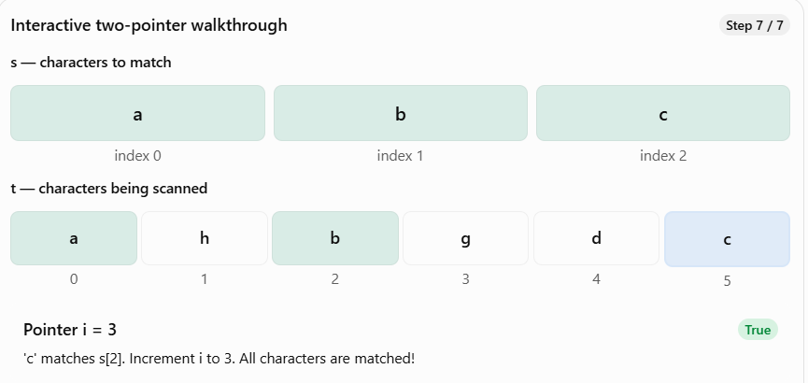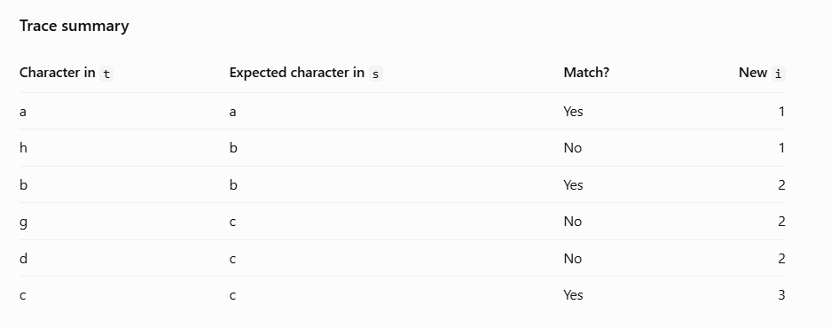

7) Valid Palindrome (#129)
A phrase is a palindrome if, after converting all uppercase letters into lowercase letters and removing all non-alphanumeric characters, it reads the same forward and backward. Alphanumeric characters include letters and numbers.
Given a string s, return true if it is a palindrome, or false otherwise.

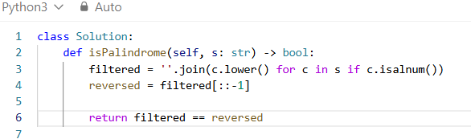
filtered = ''.join(c.lower() for c in s if c.isalnum())
- This line performs three operations:
- Filters out non-alphanumeric characters.
- Converts the remaining characters to lowercase.
- Combines them into a new string.
- Part A: for c in s
- This iterates through each character of the string.
- Part B: if c.isalnum()
- The isalnum() method returns True if the character is a letter or number.
- Only alphanumeric characters are retained.
- Part C: c.lower()
- Converts each retained character to lowercase.
- Numbers remain unchanged.
- Part D: ''.join(...)
- The join() method combines the generated characters into one string.
- The empty string '' before .join() means no separator is inserted.
reversed = filtered[::-1]
- This reverses the filtered string using Python slicing.
- The general slicing syntax is:
- sequence[start:stop:step]
- In [::-1]:
- start is omitted, so Python starts from the appropriate end for the step.
- stop is omitted, so the entire sequence is included.
- step = -1 means move backwards one character at a time.
return filtered == reversed
- Compares the filtered string with its reversed version.
- If both are identical, Python returns True; otherwise, it returns False.
TWO POINTER
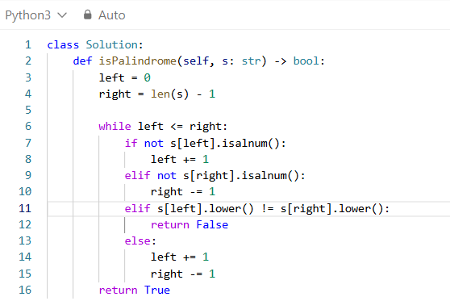
left = 0
- Initializes the left pointer at the beginning of the string.
right = len(s) - 1
- Initializes the right pointer at the last character.
- For a string of length 7, the last index is 6.
while left < right:
- Continues comparing characters while the left pointer is before the right pointer.
- Once they meet or cross, every required pair has been checked.
if not s[left].isalnum():
- Checks whether the left character is invalid.
- If it is a space or punctuation mark, we skip it.
left += 1
- Moves the left pointer one position to the right.
elif not s[right].isalnum():
- Checks whether the right character is invalid.
right -= 1
- Moves the right pointer one position to the left.
elif s[left].lower() != s[right].lower():
- If both characters are alphanumeric, compare them without considering case.
- If they differ, the string cannot be a palindrome.
return False
- Immediately stops and returns False when a mismatch is found.
else:
- This executes when both characters are valid and equal after converting to lowercase.
left += 1 and right -= 1
- Move both pointers inward to compare the next pair.
return True
- If the loop finishes without finding any mismatch, the string is a valid palindrome.

8) Reverse Words in a String (#151)
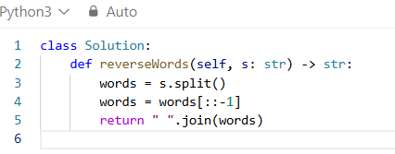
We need to perform three operations:
1. Separate the words while removing unnecessary spaces.
2. Reverse the order of the words, not the characters.
3. Join the words with exactly one space.
Python has built-in operations for all three.
words = s.split()
- The split() method, when called without arguments, separates a string using whitespace and ignores leading, trailing, and repeated whitespace.
- For example:
- s = " the sky is blue "words = s.split()
- Result: ["the", "sky", "is", "blue"]
- Notice that all the unnecessary spaces have disappeared.
- Important: Use split() rather than split(" ").
- For example:
- " hello world ".split()
- # ['hello', 'world']
- " hello world ".split(" ")
- # [' ', ' ', 'hello', ' ', ' ', 'world', ' ', ' ']
- The second version produces empty strings because it splits on every individual space.
- words = words[::-1]
- This reverses the list.
- Before: ["the", "sky", "is", "blue"]
- After: ["blue", "is", "sky", "the"]
- Remember Python slicing syntax:
- sequence[start:stop:step]
- Here, [::-1] means traverse the entire sequence backward.
- Notice that we reverse the list of words, not the individual characters.
return " ".join(words)
- The join() method combines the words into a string.
- The string before .join() is the separator.
- Here: " " is a single space.
- So: " ".join(["blue", "is", "sky", "the"])
- produces: "blue is sky the"
TRACING
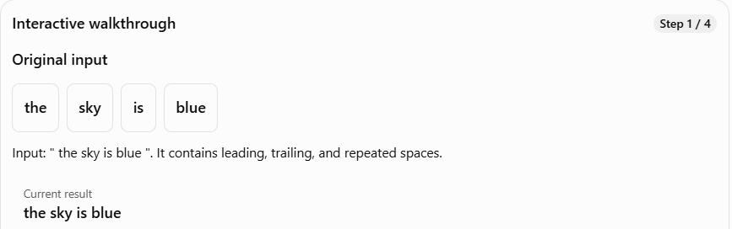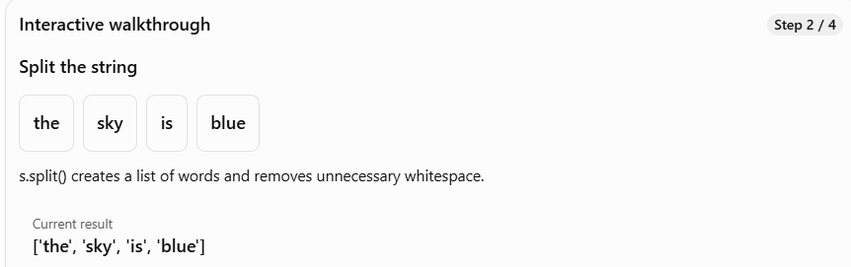

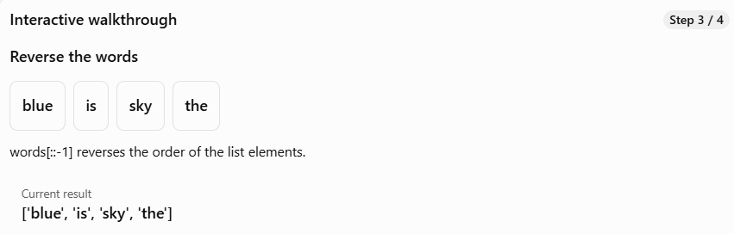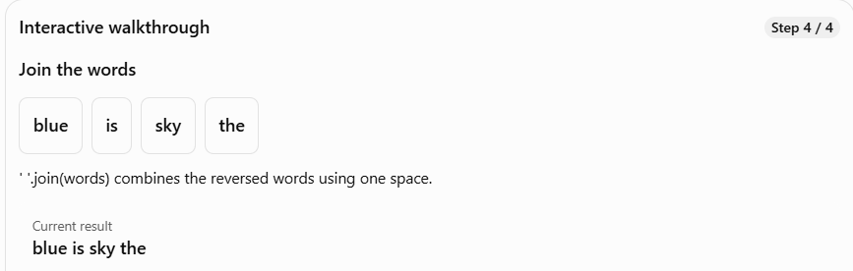

9) Single Number (#136)
Given a non-empty array of integers nums, every element appears twice except for one. Find that single one.
You must implement a solution with a linear runtime complexity and use only constant extra space
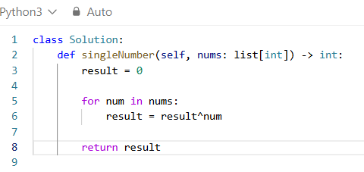
What is XOR?
- XOR stands for Exclusive OR.
- It is a bitwise operator represented by ^ in Python.
- It compares the binary digits (bits) of two numbers.
The rules are:
First bit Second bit XOR result
0 0 0
0 1 1
1 0 1
1 1 0
In simple terms:
- If both bits are the same, the result is 0.
- If the bits are different, the result is 1.
result = 0
- We initialize result to zero because XOR with zero doesn't change a number.
for num in nums:
- We visit every number in the array, one by one.
result ^= num
- This is shorthand for:
- result = result ^ num
- We combine the current number with the accumulated XOR result.
- When the same number appears for the second time, its contribution cancels out.
return result
- After processing every element, only the number that appeared once remains.
TRACING
nums = [4, 1, 2, 1, 2]
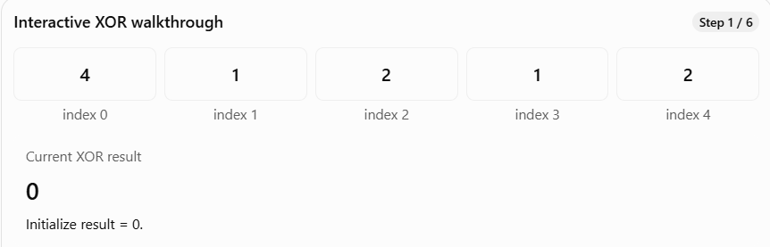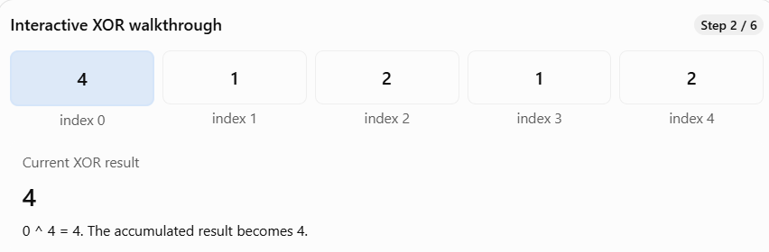

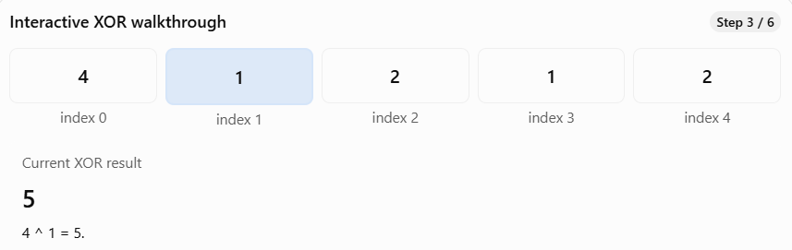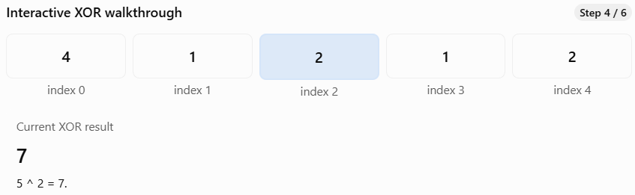
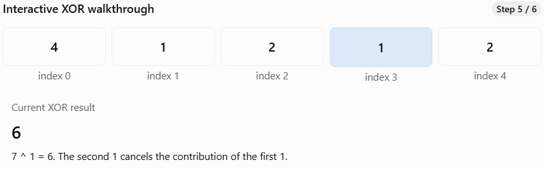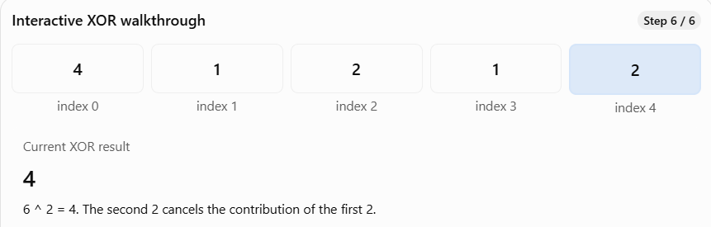
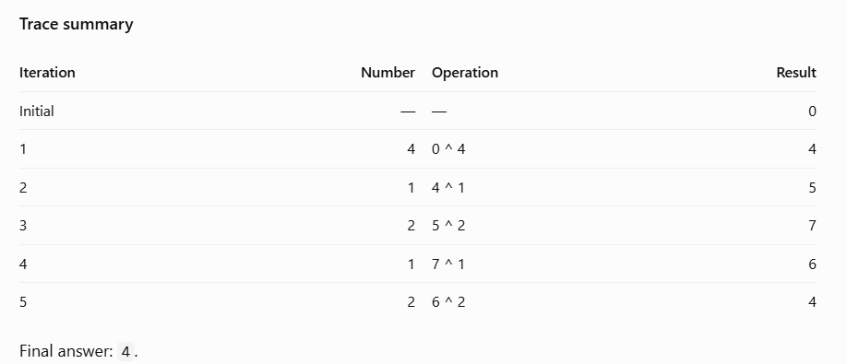

10) Counting Bits (#388)
Given an integer n, return an array ans of length n + 1 such that for each i (0 <= i <= n), ans[i] is the number of 1's in the binary representation of i.
Do not solve it with built-in functions (i.e., like __builtin_popcount in C++).
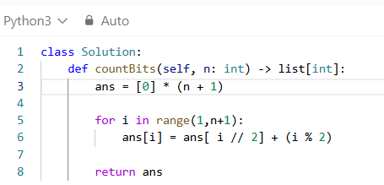
Initialize the result array
ans = [0] * (n + 1)
- For n = 5:
- ans = [0, 0, 0, 0, 0, 0]
- Each index represents a number, and its value will store the number of 1 bits.
- We already know that ans[0] = 0, because the binary representation of zero contains no 1 bits.
for i in range(1, n + 1):
- We calculate the answers in increasing order.
- This matters because i // 2 is always smaller than i for positive integers, so its answer has already been calculated.
ans[i] = ans[i // 2] + (i % 2)
- Let's take i = 5.
- i // 2 = 2
- i % 2 = 1
- We already calculated:
- ans[2] = 1
- Therefore:
- ans[5] = ans[2] + 1ans[5] = 1 + 1ans[5] = 2
- Which is correct because 5 in binary is 101, containing two 1 bits.
return ans
- Returns the bit counts for every number from 0 through n.

TRACING
N = 5
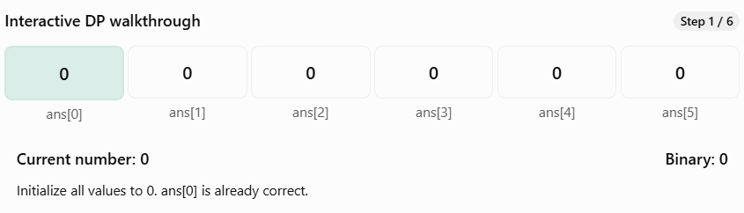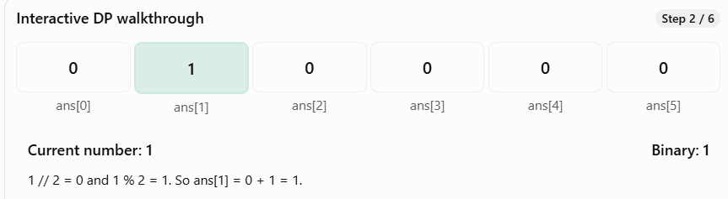
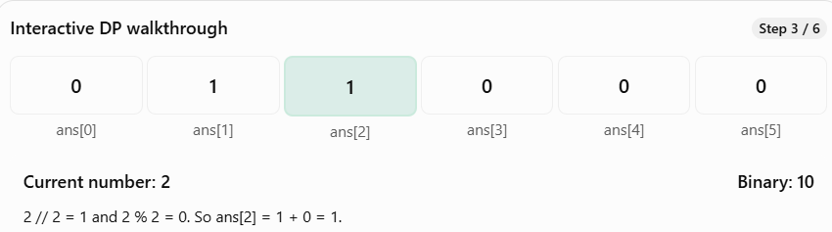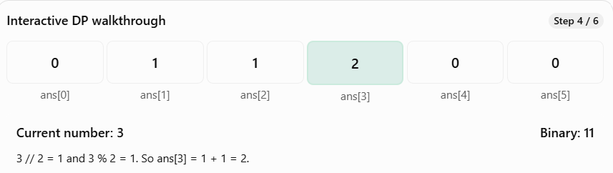
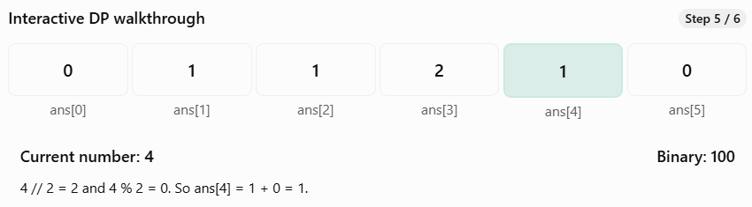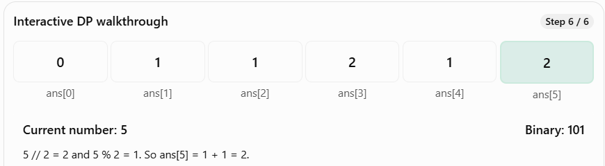
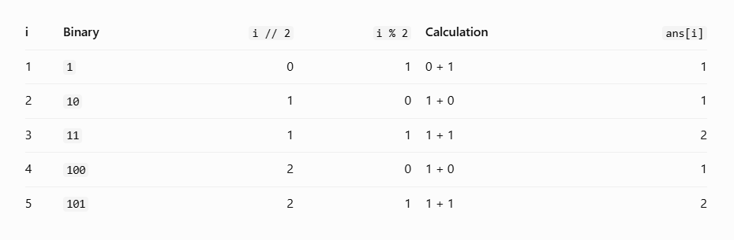
what is Dynamic Programming?
Dynamic Programming is a technique where we:
- Break a problem into smaller subproblems.
- Solve those smaller subproblems.
- Store their answers.
- Reuse those answers to solve larger subproblems.
The main idea is to avoid recalculating answers that are already available.
There are two common approaches to DP:
- Memoization (top-down): Recursion with stored results.
- Tabulation (bottom-up): Build answers iteratively from smaller to larger subproblems.
Our Counting Bits solution uses bottom-up tabulation.
The most important line is:
ans[i] = ans[i // 2] + (i % 2)
This is called the DP recurrence relation.
It means:
To calculate the answer for i, use the previously calculated answer for i // 2, then add 1 if i is odd.

11) Single Number III (#260)
Given an integer array nums, in which exactly two elements appear only once and all the other elements appear exactly twice. Find the two elements that appear only once. You can return the answer in any order.
You must write an algorithm that runs in linear runtime complexity and uses only constant extra space.
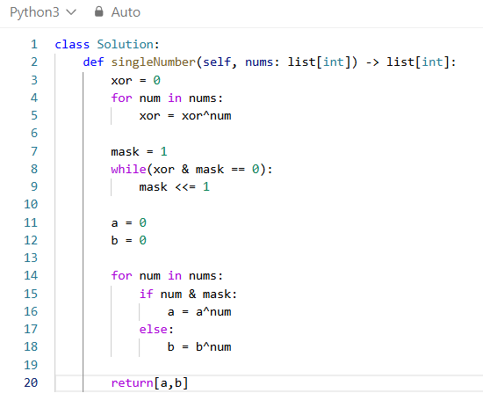
xor = 0
- We create a variable called xor and initialize it to zero.
- Why zero? Because XOR with zero leaves a number unchanged.
- 0 ^ 5 = 5
- 0 ^ 3 = 3
for num in nums: xor ^= num
- xor ^= num is shorthand for: xor = xor ^ num
- We XOR each element with the current result.
Iteration num Operation xor
Start — — 0
1 1 0 ^ 1 1
2 2 1 ^ 2 3
3 1 3 ^ 1 2
4 3 2 ^ 3 1
5 2 1 ^ 2 3
6 5 3 ^ 5 6
At the end:
xor = 6
Why 6?
- Because the two copies of 1 cancel, and the two copies of 2 cancel.
- Only the unique numbers remain in the XOR expression:
- 3 ^ 5 = 6
- Important: xor = 6 is not the answer. It is the XOR of our two answers.
mask = 1
- A mask is a number whose bits we use to examine specific bit positions in another number.
- Here, we start with 1, which is binary 001.
Decimal Binary
1 001
2 010
4 100
8 1000
- Each of these numbers has exactly one bit set to 1.
- We'll move that bit until we find a position where the two unique numbers differ.
while (xor & mask) == 0:
- This means: Keep looping while the bit selected by mask is not set in xor.
- Remember, & is bitwise AND, not XOR.
- For AND, the result is 1 only when both bits are 1.

Bit A Bit B A & B
0 0 0
0 1 0
1 0 0
1 1 1
Let's evaluate the condition.
We know:
xor = 6 mask = 1
Binary:
xor = 110
mask = 001
------------
AND = 000
So:
(6 & 1) == 0 is True.
That means the loop executes.
mask <<= 1
- This is shorthand for:
- mask = mask << 1
- << 1 shifts all the bits one position to the left.
For positive integers, shifting left by one is equivalent to multiplying by 2.
001 << 1 = 010
So: mask = 2
Now the while condition runs again:
xor = 110
mask = 010
------------
AND = 010
The result is 2, not zero.
Therefore:
(6 & 2) == 0 is False, and the loop stops.
Our final mask is 2.
Why did we do this?
Our two unique numbers are:
3 = 011
5 = 101
Look at the middle bit:
3 = 0 1 1
5 = 1 0 1
↑
Different
The middle bit is 1 in 3 and 0 in 5.
That means we can use this bit to put 3 and 5 into separate groups.
a = 0
b = 0
- We create two variables because we need to find two unique numbers.
- a will accumulate XOR values for numbers where the selected bit is 1.
- b will accumulate XOR values for numbers where the selected bit is 0.
- Initially, both are zero.

for num in nums:
- We loop through the entire array again.
- This time, instead of XORing everything together, we divide the numbers into two groups.
if num & mask:
- This checks whether the bit selected by mask is 1 in the current number.
- We know: mask = 2
- Let's check each number.
num Binary num & 2 Condition
1 001 0 False
2 010 2 True
1 001 0 False
3 011 2 True
2 010 2 True
5 101 0 False
if num & mask: a ^= num
When the condition is True, XOR the number into a.
For our example, Group A contains:
[2, 3, 2]
Calculation:
a = 0
a = 0 ^ 2 = 2
a = 2 ^ 3 = 1
a = 1 ^ 2 = 3
At the end:
a = 3
The duplicate 2 cancels itself.
else: b ^= num
When the selected bit is 0, XOR the number into b.
Group B contains:
[1, 1, 5]
Calculation:
b = 0
b = 0 ^ 1 = 1
b = 1 ^ 1 = 0
b = 0 ^ 5 = 5
At the end:
b = 5
The duplicate 1 cancels itself.
return [a, b]
- After the second loop:
- a = 3b = 5
- Therefore:
- return [3, 5]
Why are we using two loops?
The first loop:
- for num in nums: xor ^= num
- helps us find a bit where the two unique numbers differ.
The second loop:
- for num in nums: if num & mask: a ^= num else: b ^= num
- uses that bit to separate the numbers and find each unique number.
- We cannot perform the grouping until we know which bit to use.
TRACING
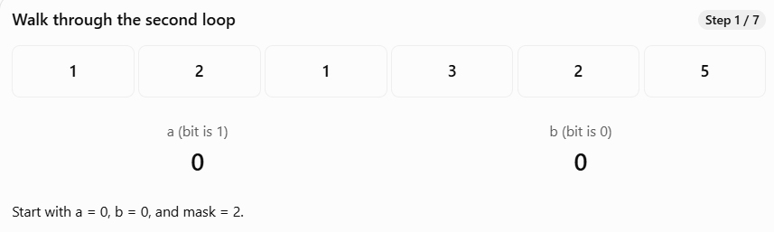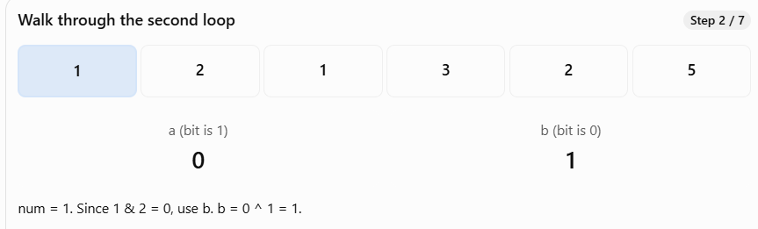
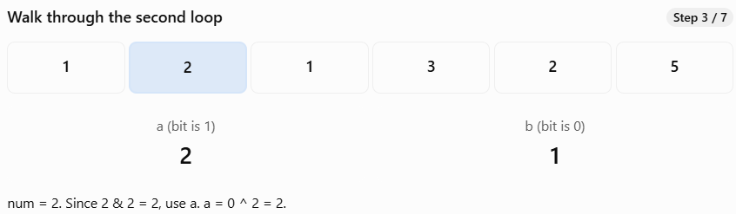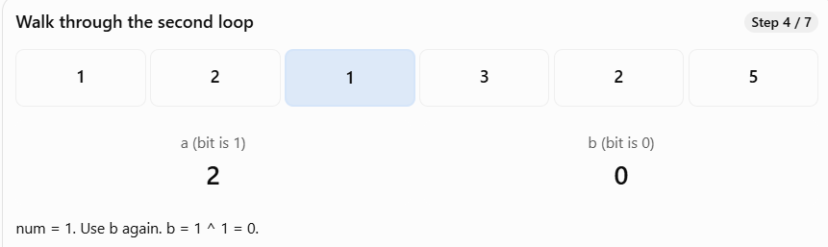
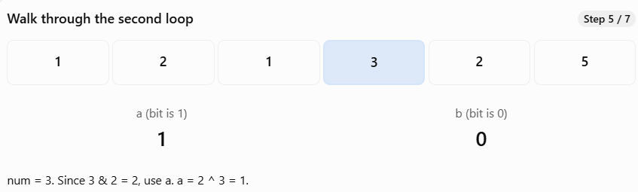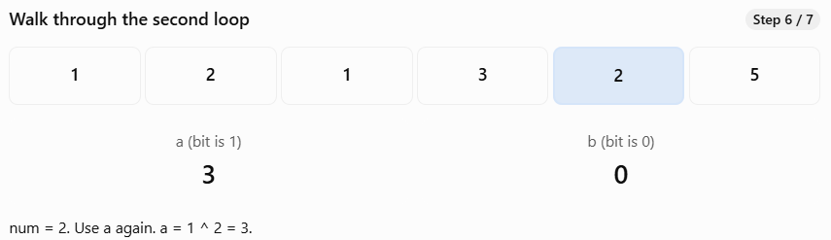
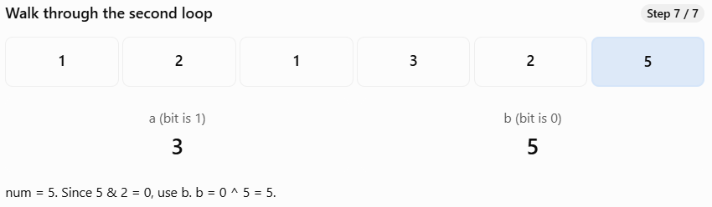

12) Isomorphic Strings (#205)
Given two strings s and t, determine if they are isomorphic.
Two strings s and t are isomorphic if the characters in s can be replaced to get t.
All occurrences of a character must be replaced with another character while preserving the order of characters. No two characters may map to the same character, but a character may map to itself.
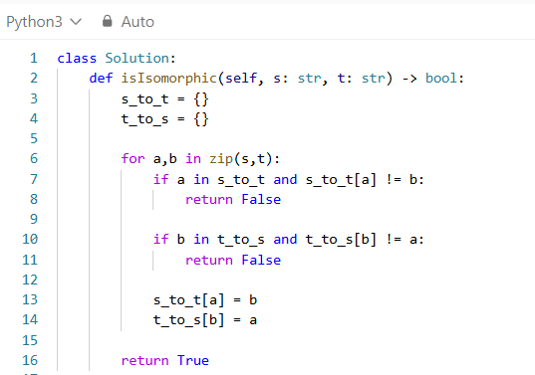
s_to_t = {}
t_to_s = {}
- A dictionary stores information as key-value pairs.
For example:
mapping = {"p": "t"}
Here:
- "p" is the key.
- "t" is the value.
We can access the value using its key:
mapping["p"] # "t"
Why s_to_t?
This dictionary remembers which character in t corresponds to each character in s.
For example:
s_to_t = { "p": "t", "a": "i"}
It tells us that p must always map to t, and a must always map to i.
Why t_to_s?
This dictionary remembers the reverse relationship.
t_to_s = { "t": "p", "i": "a"}
It prevents two different source characters from mapping to the same target character.
Think of the two dictionaries as checking both directions of a relationship.
for a, b in zip(s, t):
- This is an important Python concept.
- zip(s, t) pairs characters at corresponding positions.
For:
s = "paper"t = "title"
The pairs are:
Iteration a from s b from t
1 p t
2 a i
3 p t
4 e l
5 r e
- This is equivalent to writing:
- for i in range(len(s)): a = s[i] b = t[i]
- Using zip() simply makes the code shorter.
if a in s_to_t and s_to_t[a] != b:
return False
Condition A: a in s_to_t
- This asks:
- Have we already seen this character from s?
For example:
s_to_t = {"p": "t"}a = "p"
Then:
a in s_to_t
is True, because "p" is already a key in the dictionary.
But if:
a = "a"
then:
a in s_to_t
is False, because "a" hasn't been stored yet.
Condition B: s_to_t[a] != b
- This asks:
- Does the previously stored mapping differ from the character we are currently trying to map to?
For example:
s_to_t = {"p": "t"}a = "p"b = "x"
Then:
s_to_t[a] != b
becomes:
"t" != "x"

This is True.
It means p was previously mapped to t, but now we're trying to map it to x.
That is invalid.
Why use and?
if a in s_to_t and s_to_t[a] != b:
Both conditions must be True for the function to return False.
Character seen before? Mapping different? Return False?
No Not checked No
Yes No No
Yes Yes Yes
Python uses short-circuit evaluation. If a in s_to_t is False, Python doesn't evaluate s_to_t[a] != b.
This also prevents an error when the key doesn't exist.
Example where the first condition fails
s = "foo"t = "bar"
Let's trace it:
Iteration a b Dictionary before checking
1 f b {}
2 o a {"f":"b"}
3 o r {"f":"b","o":"a"}
At iteration 3:
a = "o"b = "r"
Now evaluate:
a in s_to_t
"o" exists, so True.
Then:
s_to_t["o"] != "r"
The stored value is "a".
So:
"a" != "r" # True
Both conditions are True.
Therefore:
return False
The function stops immediately.
if b in t_to_s and t_to_s[b] != a:
return False
This looks similar to the first condition, but it checks the opposite direction.
Let's use a different example:
s = "ab"t = "cc"
First pair:
a → c
We store:
s_to_t = {"a": "c"}t_to_s = {"c": "a"}
Second pair:
b → c
Now check the first condition:
if a in s_to_t and s_to_t[a] != b:
For this iteration, the loop variables are:
a = "b"b = "c"
"b" is not in s_to_t, so the first condition is False.

But we still have a problem: "c" is already assigned to "a".
That's what the second dictionary detects.
Evaluate:
b in t_to_s
This becomes:
"c" in {"c": "a"}
True.
Then:
t_to_s[b] != a
This becomes:
"a" != "b"
True.
Therefore:
return False
This is why checking only s_to_t is not enough. We must also ensure that no two different source characters map to the same target character.
s_to_t[a] = b
t_to_s[b] = a
These lines execute only if neither of the earlier conditions returned False.
Suppose:
a = "p"b = "t"
Then:
s_to_t["p"] = "t"
t_to_s["t"] = "p"
Both dictionaries now remember the relationship.
If we encounter p → t again, the checks pass because the existing mapping is consistent.
TRACING
"paper" and "title"
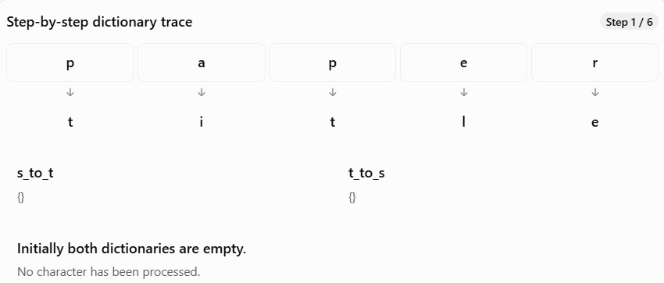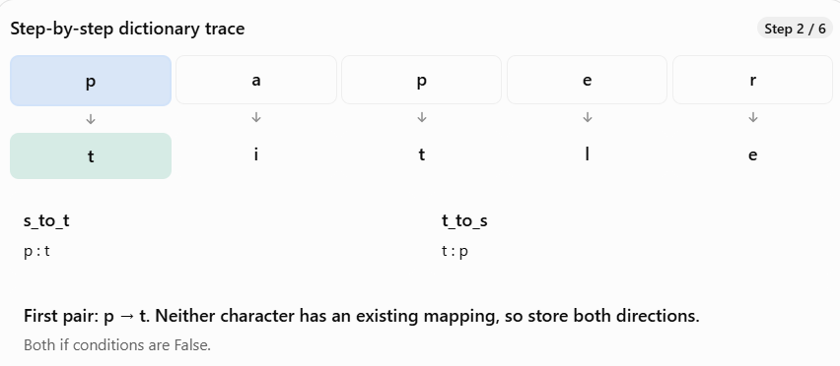
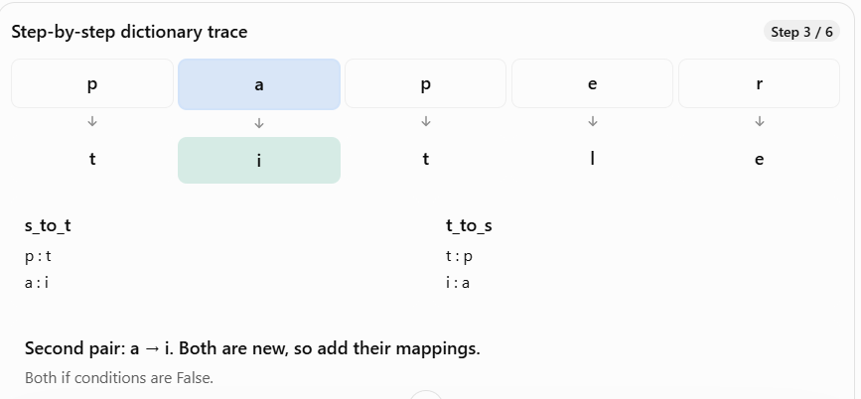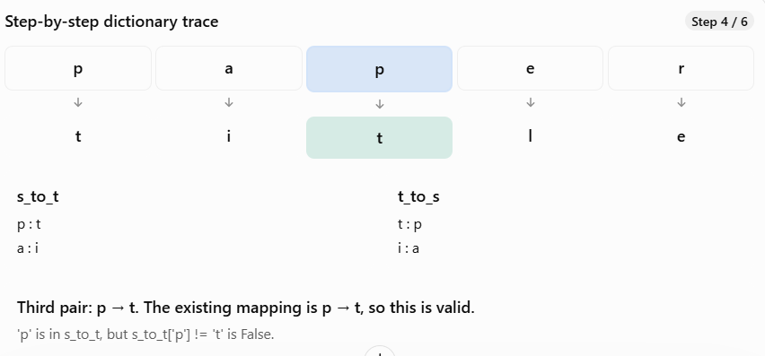
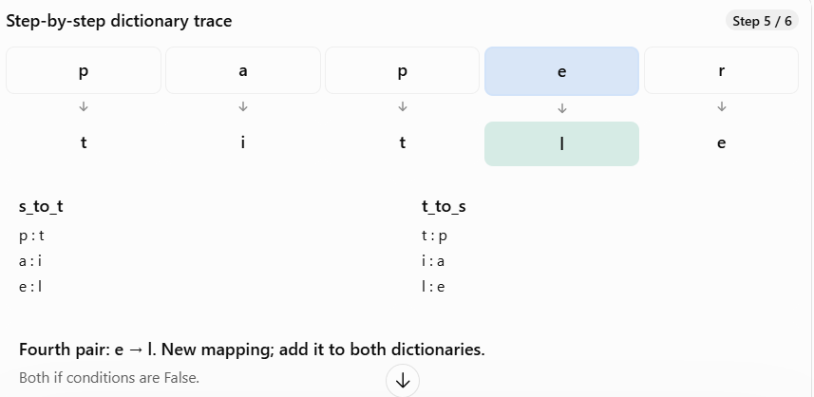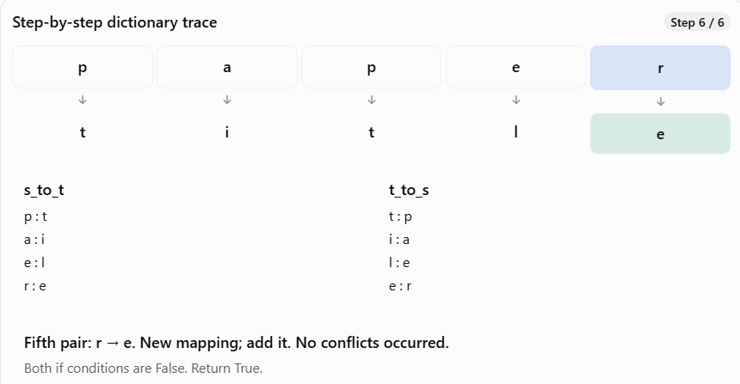

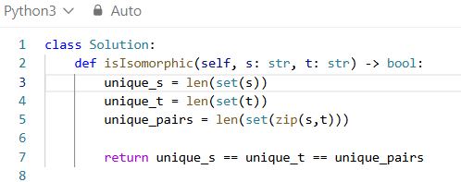
len(set(s))
- Consider: s = "egg"
- set(s) removes duplicate characters:
- set(s) # {'e', 'g'}
- Therefore: len(set(s)) # 2
- There are two distinct characters in s.
len(set(t))
- Consider: t = "add"
- set(t) # {'a', 'd'}
- Therefore: len(set(t)) # 2
- There are two distinct characters in t.
len(set(zip(s, t)))
- This is the most important part.
- First, zip(s, t) pairs characters at the same positions.
- s = "egg" t = "add" list(zip(s, t))
- Result:
- [('e', 'a'), ('g', 'd'), ('g', 'd')]
- Now apply set():
- set(zip(s, t))
- Result:
- {('e', 'a'), ('g', 'd')}
- The repeated pair ('g', 'd') is removed.
- So:
- len(set(zip(s, t))) # 2
All three counts are equal:
2 == 2 == 2
Therefore, return True.

13) Contains Duplicate II (#219)
Given an integer array nums and an integer k, return true if there are two distinct indices i and j in the array such that nums[i] == nums[j] and abs(i - j) <= k.
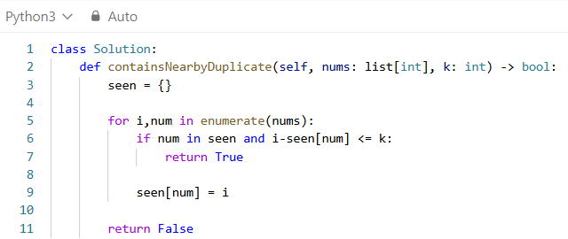

seen = {}
- We create an empty dictionary called seen.
- This dictionary stores:
- Key: Number from the array.
- Value: Most recent index where that number appeared.
- For example:
- seen = { 1: 0, 2: 1, 3: 2}
- This means 1 appeared at index 0, 2 at index 1, and 3 at index 2.
- Why a dictionary?
- Because we can check whether a number already exists in approximately O(1) time.
for i, num in enumerate(nums):
- We iterate through the array using enumerate().
- enumerate() gives us both the index and the value.
- For example:
- nums = [1, 2, 3, 1]
Iteration i (index) num (value)
1 0 1
2 1 2
3 2 3
4 3 1
- We need the index because the problem asks us to calculate the distance between two positions.
if num in seen and i - seen[num] <= k:
- This is the most important line.
- It checks two conditions using and.
- Condition 1: num in seen
- Checks whether we have encountered the same number before.
- For example:
- seen = {1: 0, 2: 1, 3: 2}num = 1
- Since 1 already exists in seen, the condition is True.
- Condition 2: i - seen[num] <= k
- Checks whether the current index and previous index are close enough.
- Suppose:
- i = 3 seen [1] = 0 k = 3
- Then:
- 3 - 0 <= 3 3 <= 3 # True
- Both conditions are satisfied.
Why don't we use abs ()?
- Because we are iterating from left to right. The current index i is always greater than the previously stored index, so the difference is already nonnegative.
return True
- If both conditions are satisfied, we immediately return True.
- We don't need to check the remaining elements because the problem only asks whether at least one valid pair exists.
seen[num] = i
- We store the current number and its index in the dictionary.
- For example:
- num = 2 i = 1 seen [2] = 1
- The dictionary becomes:
- seen = {1: 0, 2: 1}
- But what if the number already exists?
- Suppose:
- seen = {1: 0, 2: 1} num = 1 i = 3
- Then:
- seen [1] = 3
- The dictionary becomes:
- seen = {1: 3, 2: 1}
- We overwrite the old index with the latest index.
Why is this important? Because the most recent occurrence is always the closest previous occurrence to the current position. If even that occurrence is too far away, all older occurrences are also too far away.
return False
- If we finish checking the entire array without finding any valid duplicate pair, return False.

TRACING
nums = [1, 2, 3, 1]
k = 3
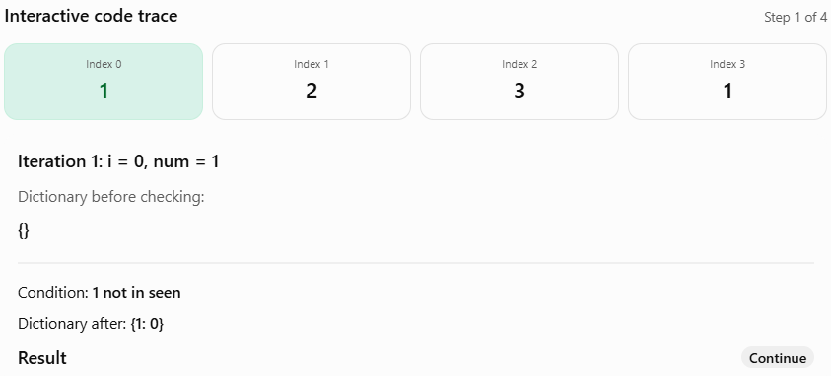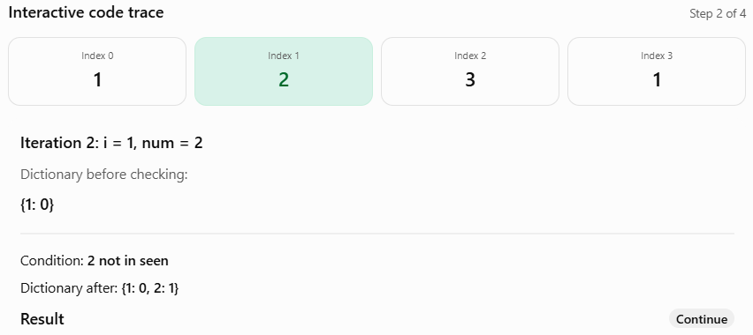
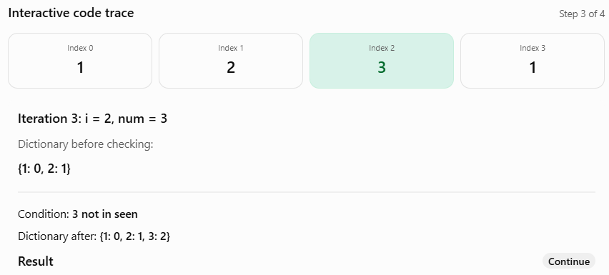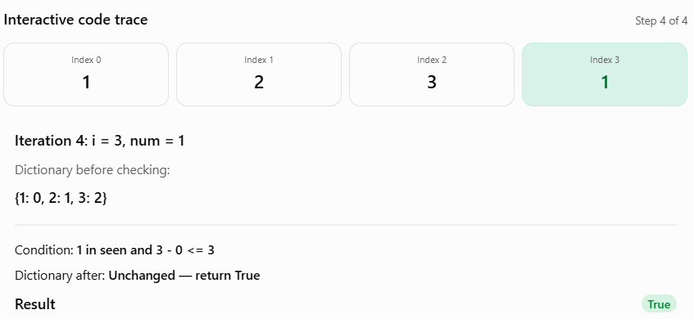
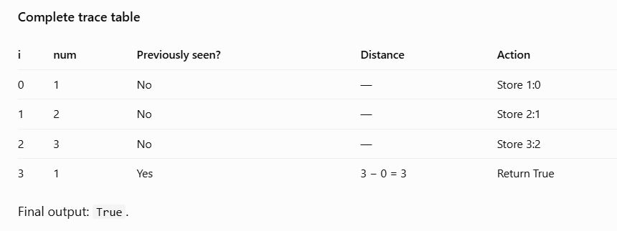
14) Group Anagrams(#49)
Given an array of strings strs, group the anagrams together. You can return the answer in any order.
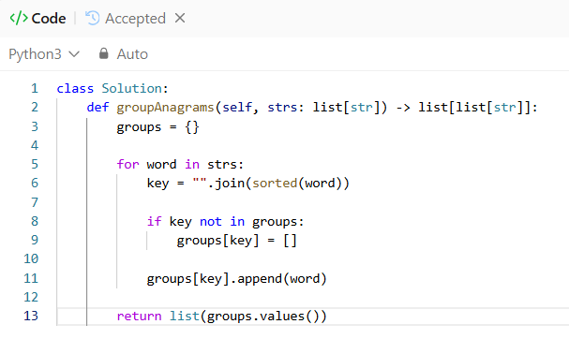
Create a dictionary
groups = {}
- We create an empty dictionary called groups.
- This dictionary will store:
  - Key: The sorted version of a word.
  - Value: A list of all the words that are anagrams of each other.
Initially:
groups = {}
Eventually, it will look like:
groups = { "aet": ["eat", "tea", "ate"], "ant": ["tan", "nat"], "abt": ["bat"]}
for word in strs:
- We iterate through each string in the input array.
For example:
strs = ["eat", "tea", "tan", "ate", "nat", "bat"]
Iteration word
1 "eat"
2 "tea"
3 "tan"
4 "ate"
5 "nat"
6 "bat"
- During each iteration, we process one word.
key = "".join(sorted(word))
- This is the most important line in the solution.
- Let's break it into two parts.
sorted(word)
- Suppose:
- word = "eat"
- When we execute:
- sorted(word)
- Python sorts the characters alphabetically and returns a list:
- ['a', 'e', 't']
- Notice that sorted() returns a list, not a string.
"".join(...)
- "".join(['a', 'e', 't'])
- The join() method combines all the characters into a single string.
- The empty string "" means we don't want any separator between the characters.
- Result: "aet"
Therefore:
key = "".join(sorted("eat"))
- Becomes:
- key = "aet"
Here are a few more examples:
word sorted(word) key
"eat" ['a', 'e', 't'] "aet"
"tea" ['a', 'e', 't'] "aet"
"tan" ['a', 'n', 't'] "ant"
"ate" ['a', 'e', 't'] "aet"
"nat" ['a', 'n', 't'] "ant"
"bat" ['a', 'b', 't'] "abt"
Why do we need join()?
- Because dictionary keys must be hashable. A Python list cannot be used as a dictionary key, but a string can.
- groups [['a', 'e', 't']] = [] # Errorgroups ["aet"] = [] # Valid
if key not in groups:
- We check whether the sorted string already exists in our dictionary.
- Suppose we are processing "eat".
- key = "aet"groups = {}
- We check:
- if "aet" not in groups:
- Since the dictionary is empty, the condition is True.
- This means we haven't created a group for these anagrams yet.
groups[key] = []
- We create an empty list for the new key.
- For example:
- groups["aet"] = []
- Now our dictionary becomes:
- groups = { "aet": []}
Why an empty list?
- Because we may have multiple words belonging to the same anagram group, and we need to store all of them.
groups[key].append(word)
- We add the original word to the corresponding group.
- Suppose:
- word = "eat"key = "aet"
- Then:
- groups["aet"].append("eat")
- The dictionary becomes:
- groups = { "aet": ["eat"]}
- When we process "tea" next:
- word = "tea"key = "aet"
- The key "aet" already exists, so we don't create a new empty list.
- Instead, we directly append:
- groups["aet"].append("tea")
- The dictionary becomes:
- groups = { "aet": ["eat", "tea"]}
- Important: We append the original word, not the sorted word, because the output should contain the original strings.
return list(groups.values())
- After processing all the words, our dictionary looks like:
- groups = { "aet": ["eat", "tea", "ate"], "ant": ["tan", "nat"], "abt": ["bat"]}
- We don't need the dictionary keys in the output. We only need the lists of words.
- Step 1: groups.values()
- dict_values([ ["eat", "tea", "ate"], ["tan", "nat"], ["bat"]])
- Step 2: list(groups.values())
- Converts the dictionary values into a list:
- [ ["eat", "tea", "ate"], ["tan", "nat"], ["bat"]]
- This is our final answer.
TRACING
strs = ["eat", "tea", "tan", "ate", "nat", "bat"]
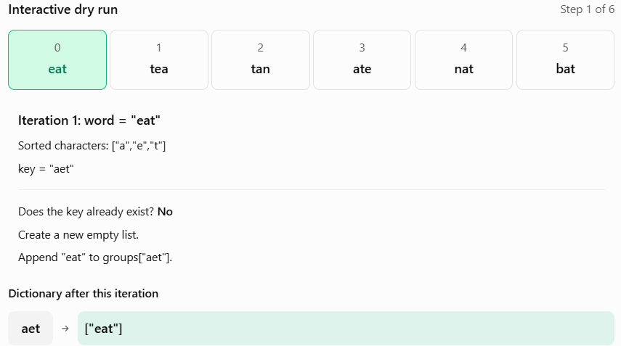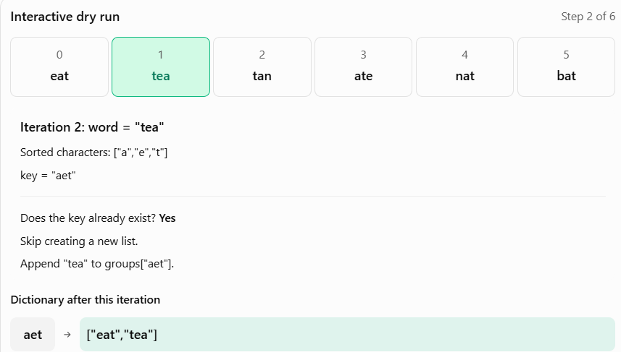
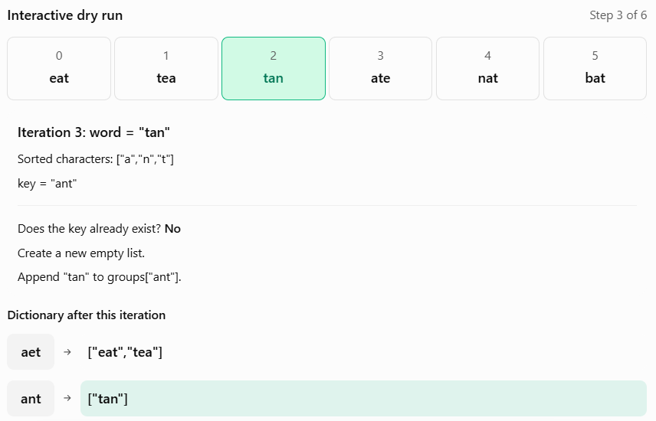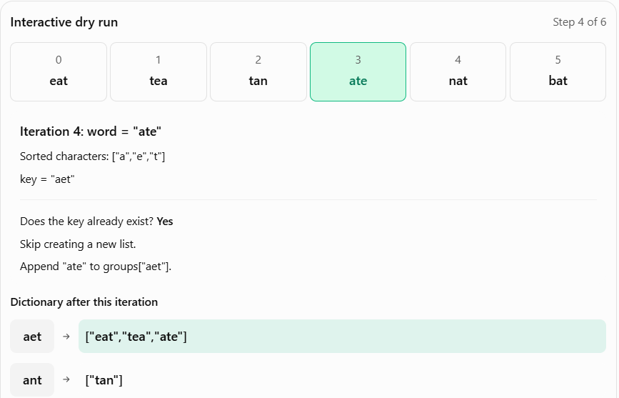

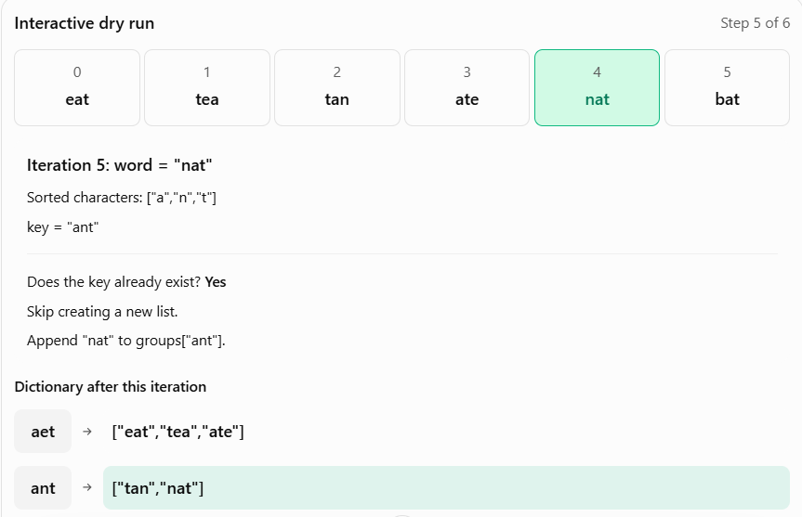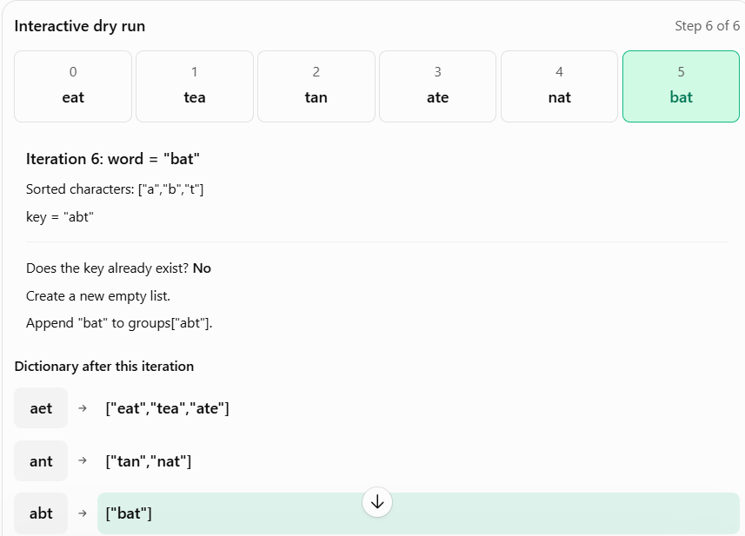
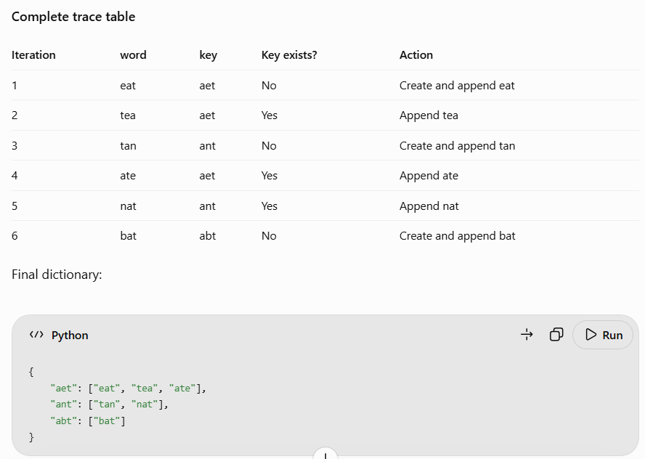

15) Encode and Decode TinyURL (#535)
Note: This is a companion problem to the System Design problem: Design TinyURL.
TinyURL is a URL shortening service where you enter a URL such as https://leetcode.com/problems/design-tinyurl and it returns a short URL such as http://tinyurl.com/4e9iAk. Design a class to encode a URL and decode a tiny URL.
There is no restriction on how your encode/decode algorithm should work. You just need to ensure that a URL can be encoded to a tiny URL and the tiny URL can be decoded to the original URL.
Implement the Solution class:
Solution() Initializes the object of the system.
String encode(String longUrl) Returns a tiny URL for the given longUrl.
String decode(String shortUrl) Returns the original long URL for the given shortUrl. It is guaranteed that the given shortUrl was encoded by the same object.
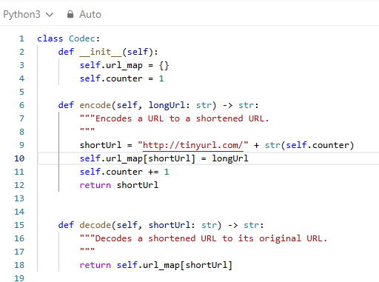
def __init__(self):
- This is the constructor. It is automatically executed when we create an object of the Solution class.
self.url_map = {}
- Creates an empty dictionary to store the mapping between short URLs and long URLs.
- Initially:
- url_map = {}
self.counter = 1
- Creates a counter starting at 1. We use this counter to generate a different short URL for every encode operation.
def encode(self, longUrl: str) -> str:
- Receives a long URL as a string and returns a short URL as a string.
shortUrl = "http://tinyurl.com/" + str(self.counter)
- Creates a short URL by combining a fixed URL prefix with the counter.
- For example, when counter = 1:
- shortUrl = http://tinyurl.com/1
- We use str(self.counter) because the counter is an integer, and Python cannot directly concatenate an integer with a string.
self.url_map[shortUrl] = longUrl
- Stores the short URL as the key and the original long URL as the value in our dictionary.
self.counter += 1
- Increases the counter by 1 so that the next URL receives a different short URL.
return shortUrl
- Returns the newly generated short URL.
def decode(self, shortUrl: str) -> str:
- Receives a short URL and returns the original long URL.
return self.url_map[shortUrl]
- Looks up the short URL in the dictionary and returns its corresponding long URL.
- We don't need to perform any complicated decoding algorithm because we have already stored the original URL.

16) Longest Consecutive Sequence (#128)
Given an unsorted array of integers nums, return the length of the longest consecutive elements sequence.
You must write an algorithm that runs in O(n) time.
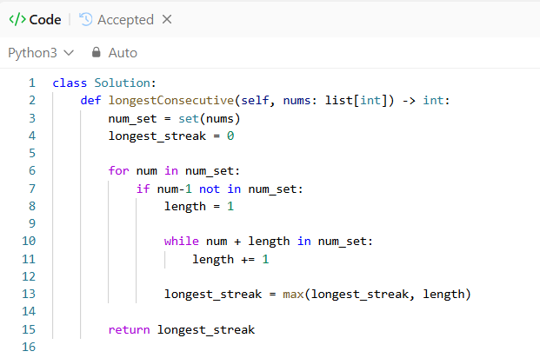
Convert the array into a set
num_set = set(nums)
- Suppose:
- nums = [100, 4, 200, 1, 3, 2]
- After converting:
- num_set = {1, 2, 3, 4, 100, 200}
- We use a set for two reasons:
- Reason 1: Fast lookup
- Checking whether a number exists in a list takes O(n) time in the worst case.
- 3 in nums
- But checking whether a number exists in a set takes O(1) time on average.
- 3 in num_set
- Since we repeatedly check whether the previous and next numbers exist, a set is much more efficient.
- Reason 2: Remove duplicates
- nums = [1, 2, 2, 3, 4]
- num_set = set(nums)
- Result:
- {1, 2, 3, 4}
- Duplicate numbers should not increase the length of a consecutive sequence.
- Note: A set does not guarantee sorted order. I am displaying its elements in ascending order here only to make the explanation easier.
longest_streak = 0
- This variable stores the maximum length of any consecutive sequence we have found so far.
- Initially, we haven't found any sequence.
- longest_streak = 0
- If we find a sequence of length 4:
- longest_streak = 4
- If we later find a sequence of length 6:
- longest_streak = 6
for num in num_set:
- We iterate through every unique number.
- For our example, we will use this illustrative iteration order:
- 1, 2, 3, 4, 100, 200
- During each iteration, num holds the current number.
if num - 1 not in num_set:
- This is the most important line in the entire solution.
- Suppose:
- num = 1 num_set = {1, 2, 3, 4, 100, 200}
- We check:
- if 1 - 1 not in num_set:
- Which becomes: if 0 not in num_set:
- Since 0 does not exist in the set, the condition is True.
- Therefore, 1 is the starting point of a consecutive sequence.
- Now suppose: num = 3
- We check: if 3 - 1 not in num_set:
- Which becomes: if 2 not in num_set:
- But 2 exists in the set, so the condition is False.
- We skip 3 because it is already part of a sequence that starts at an earlier number.
length = 1
- Once we find the beginning of a sequence, we initialize its length to 1.
- Why 1 and not 0?
- Because the current number itself is already part of the sequence.
- For example: num = 1
- Our current sequence is: [1]
- Therefore: length = 1
- Even if there are no more consecutive numbers, this sequence still contains one element.
while num + length in num_set:
- This loop checks whether the next consecutive number exists.
- Let's break it down carefully.
- Suppose: num = 1 length = 1
- Then: while 1 + 1 in num_set:
- Which means: while 2 in num_set:
- Since 2 exists, we enter the loop.
length += 1
- We found another consecutive number, so we increase the length.
- length = 2
- Our sequence is now: [1, 2]
- The while loop runs again:
while num + length in num_set:
- Now: while 1 + 2 in num_set:
- Which checks: 3 in num_set
- Since 3 exists, we increase the length again.
- length = 3
- Our sequence becomes: [1, 2, 3]
- Let's continue the complete loop.
num length before num + length Exists? length after
1 1 2 Yes 2
1 2 3 Yes 3
1 3 4 Yes 4
1 4 5 No 4
- When we check for 5, it does not exist in the set, so the loop stops.
- Final sequence: [1, 2, 3, 4] length = 4
- Important: Notice that num always remains 1. We don't modify it. Instead, length increases, allowing num + length to check the next number.
longest_streak = max(longest_streak, length)
- Once we finish counting a sequence, we compare its length with the longest sequence found so far.
- Initially: longest_streak = 0 length = 4
- We execute: longest_streak = max(0, 4)
- Result: longest_streak = 4
- Later, if we process 100, its sequence length is only 1.
- longest_streak = max(4, 1)
- Result: longest_streak = 4
- This ensures we never lose the longest sequence we have already found.
return longest_streak
- After processing all the numbers, we return the maximum sequence length.
- return 4
TRACING
nums = [100, 4, 200, 1, 3, 2]
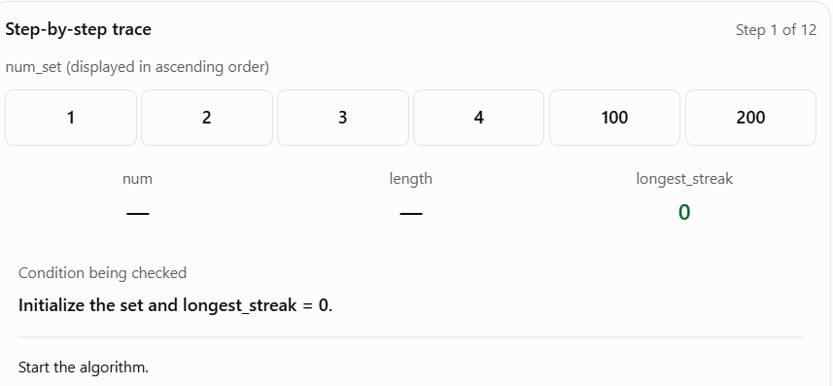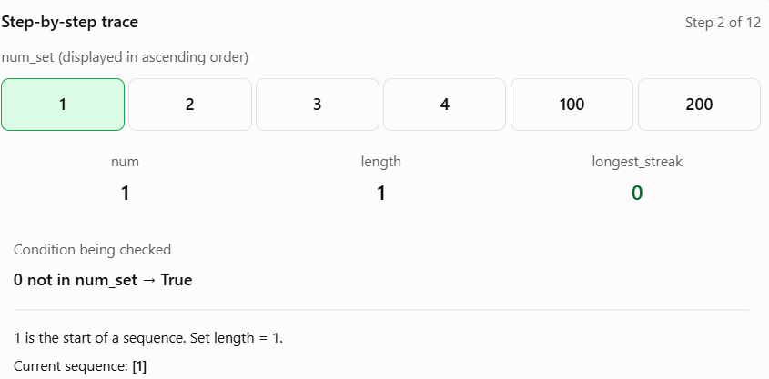
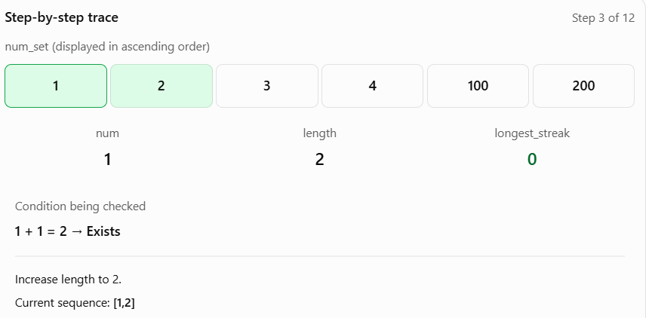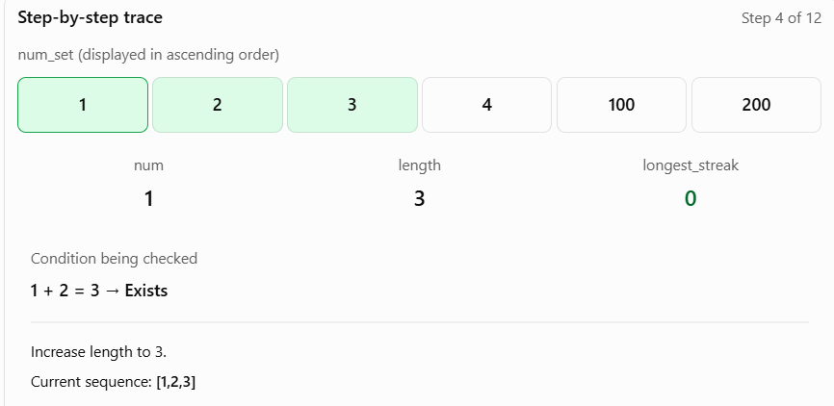
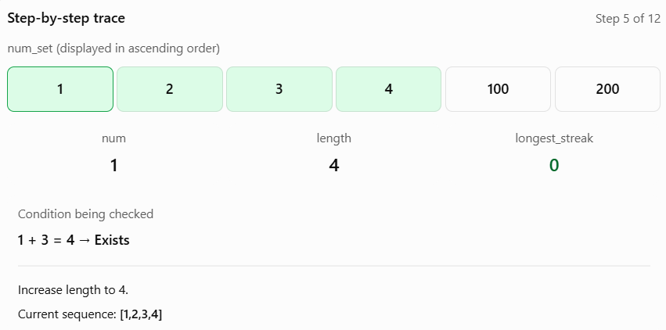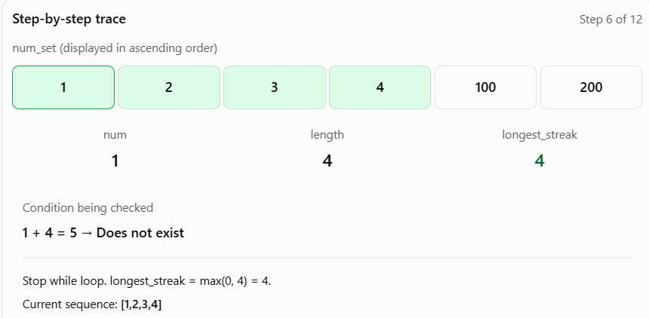
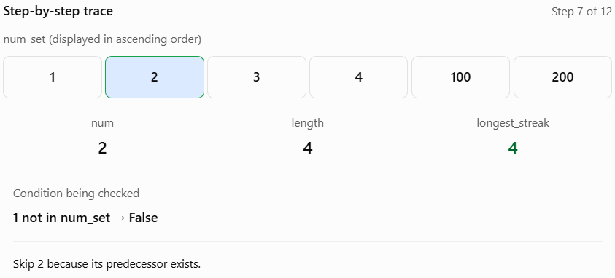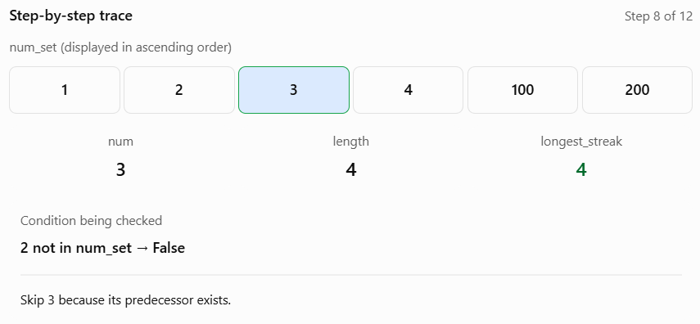
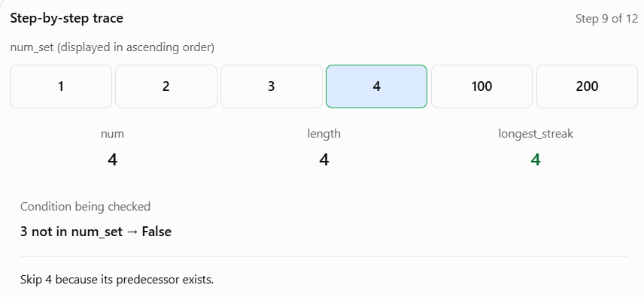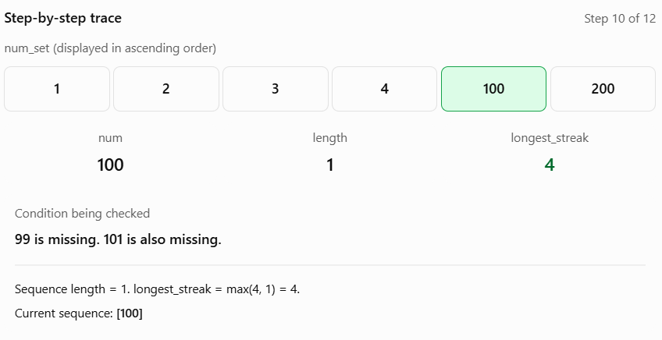
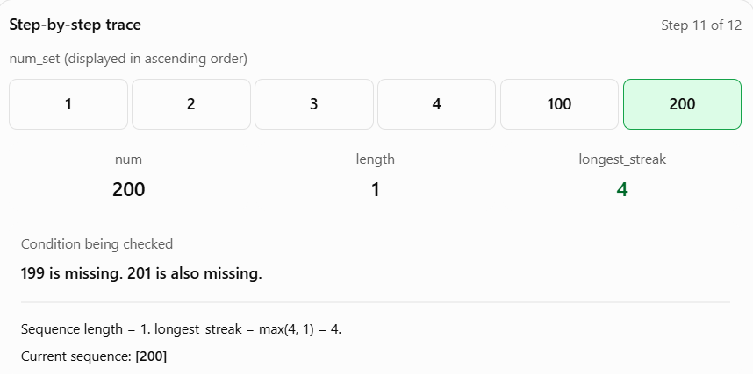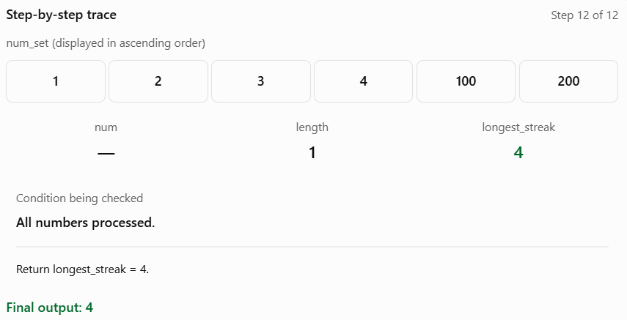
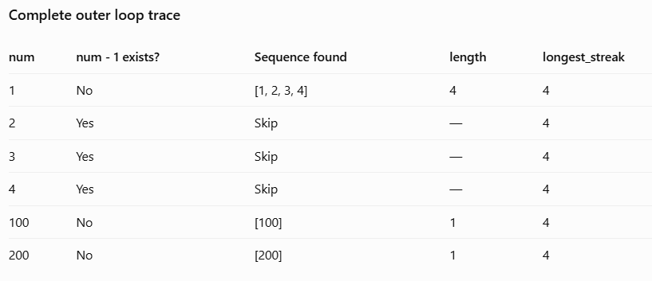

17) Two Sum II - Input Array Is Sorted (#167)
You are given a 1-indexed array of integers numbers that is already sorted in non-decreasing order.
Find two numbers such that they add up to a specific target number. Let these two numbers be numbers[index1] and numbers[index2] where 1 <= index1 < index2 <= numbers.length.
Return the indices of the two numbers index1 and index2 as an integer array [index1, index2] of length 2.
The tests are generated such that there is exactly one solution. You may not use the same element twice.
Your solution must use only constant extra space.
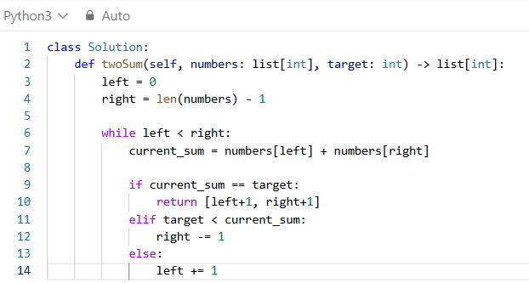

18) Container With Most Water (#11)
You are given an integer array height of length n. There are n vertical lines drawn such that the two endpoints of the i^{th} line are (i, 0) and (i, height[i]).
Find two lines that together with the x-axis form a container, such that the container contains the most water.
Return the maximum amount of water a container can store.
Notice that you may not slant the container.
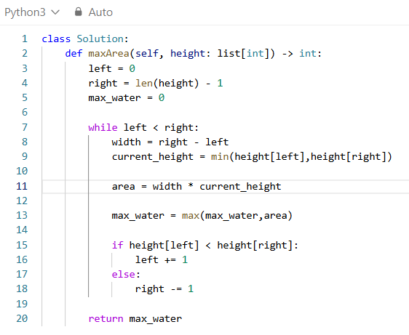
Initialize the left pointer
left = 0
- We initialize left to index 0, which represents the first vertical line.
- Remember: left stores the index, not the height.
right = len(height) - 1
- We initialize right to the last index of the array.
- Our array contains 9 elements.
max_water = 0
- This variable stores the maximum area we have found so far.
- Initially, we haven't calculated any area.
- As we calculate different container areas, we update this variable whenever we find a larger area.
while left < right:
- This loop continues as long as the left pointer is before the right pointer.
- Initially: left = 0 right = 8 while 0 < 8:
- The condition is True, so we enter the loop.
- Why do we use < instead of <=?
- Because we need two different vertical lines to form a container.
- If both pointers are at the same index:
- left = 4right = 4
- The width would be:
- width = 4 - 4 = 0
- A container with zero width cannot store water. Therefore, we stop when the pointers meet.
width = right - left
- We calculate the distance between the two selected vertical lines.
- During the first iteration:
- left = 0 right = 8 width = 8 – 0 width = 8
- Notice that the width is calculated using the indices, not the heights.
current_height = min(height[left], height[right])
- This line calculates how high the water can rise between the two selected lines.
- During the first iteration:
- left = 0 right = 8 height[left] = 1 height[right] = 7
- Therefore:
- current_height = min(1, 7)current_height = 1
- Why do we use min()?
- Because the shorter vertical line determines how much water can be held.
area = width * current_height
- We calculate the amount of water the current container can store.
max_water = max(max_water, area)
- We compare the current container area with the largest area found so far.
Difference between area and max_water:
Variable Purpose
area Water stored by the current two lines
max_water Maximum water found across all iterations
The area can increase or decrease, but max_water never decreases.
if height[left] < height[right]:
- This is the most important decision in the algorithm.
- We check whether the left vertical line is shorter than the right vertical line.
left += 1
- Since the left line is shorter, we move the left pointer one position to the right.
else: right -= 1
- If the left height is not smaller than the right height, we move the right pointer one position to the left.
return max_water
- Once the pointers meet, the while loop terminates.
- We return the maximum water found across all iterations.
TRACING
height = [1, 8, 6, 2, 5, 4, 8, 3, 7]
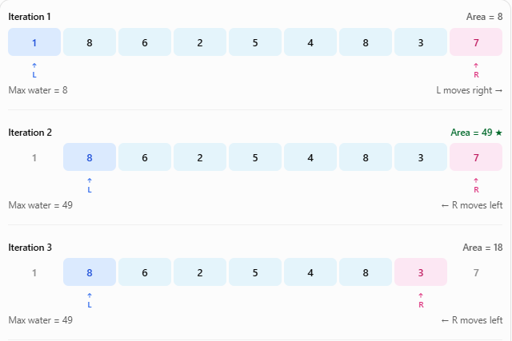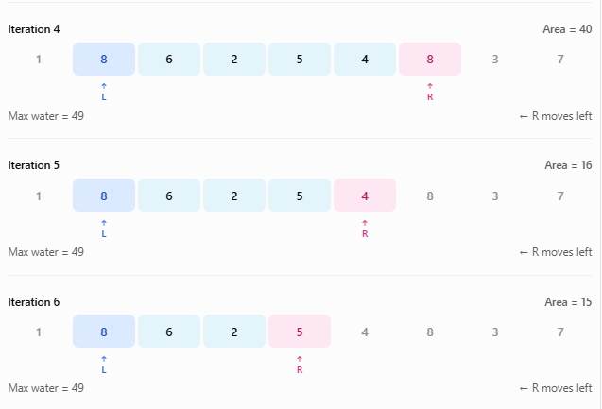
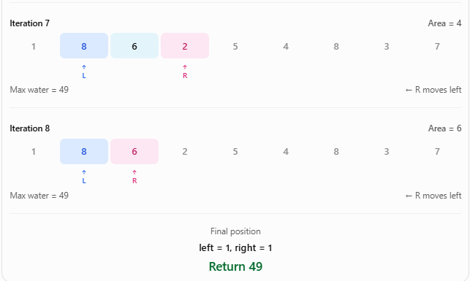
19) 3Sum (#15)
Given an integer array nums, return all the triplets [nums[i], nums[j], nums[k]] such that i != j, i != k, and j != k, and nums[i] + nums[j] + nums[k] == 0.
Notice that the solution set must not contain duplicate triplets.
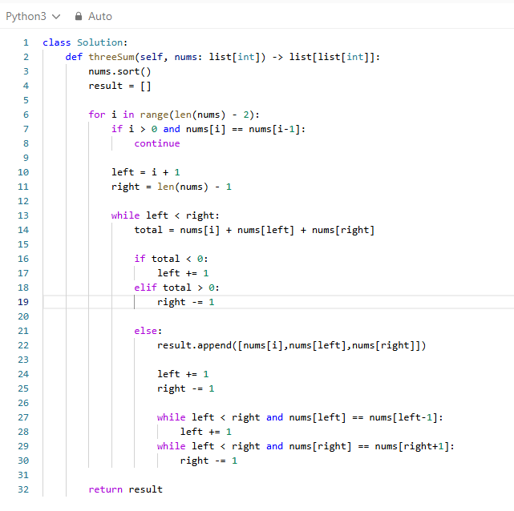
nums.sort()
- Sorts the array in ascending order. This helps us use two pointers and easily identify duplicate values.
result = []
- Creates an empty list to store all the unique triplets whose sum is zero.
for i in range(len(nums) - 2):
- Iterates through the array and fixes one number at a time. We stop at len(nums) - 2 because we need at least two more elements after the fixed number to form a triplet.
if i > 0 and nums[i] == nums[i - 1]:
continue
- Checks whether the current number is the same as the previous number. If it is, we skip the current iteration to avoid duplicate triplets.
left = i + 1
- Initializes the left pointer immediately after the fixed number.
right = len(nums) - 1
- Initializes the right pointer at the last index of the array.
while left < right:
- Continues searching while the left pointer is before the right pointer. This ensures that we use three distinct indices.
total = nums[i] + nums[left] + nums[right]
- Calculates the sum of the three selected numbers.
if total < 0:
left += 1
- If the sum is less than zero, we need a larger number. Since the array is sorted, we move the left pointer to the right.
elif total > 0:
right -= 1
- If the sum is greater than zero, we need a smaller number. We move the right pointer to the left.
else:
result.append([nums[i], nums[left], nums[right]])
- If the sum is exactly zero, we have found a valid triplet. We append the three numbers to the result list.
left += 1
right -= 1
- Moves both pointers inward to search for another valid triplet.
while left < right and nums[left] == nums[left - 1]:
left += 1
- Skips duplicate values on the left side. We compare the current left value with the previously used left value to avoid generating the same triplet again.
while left < right and nums[right] == nums[right + 1]:
right -= 1
- Skips duplicate values on the right side. We compare with right + 1 because the right pointer moves from right to left.
return result
- Returns all the unique triplets whose sum is zero after completing the search.
TRACING
nums = [-1, 0, 1, 2, -1, -4]
After executing nums.sort():
nums = [-4, -1, -1, 0, 1, 2]
result = []
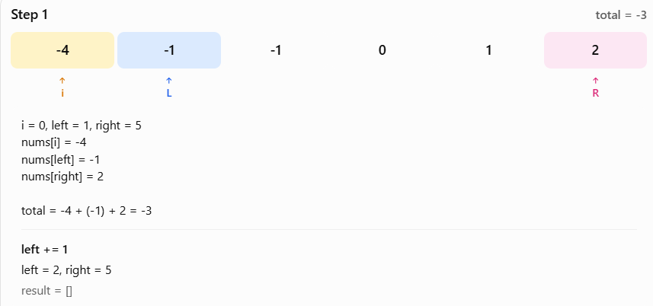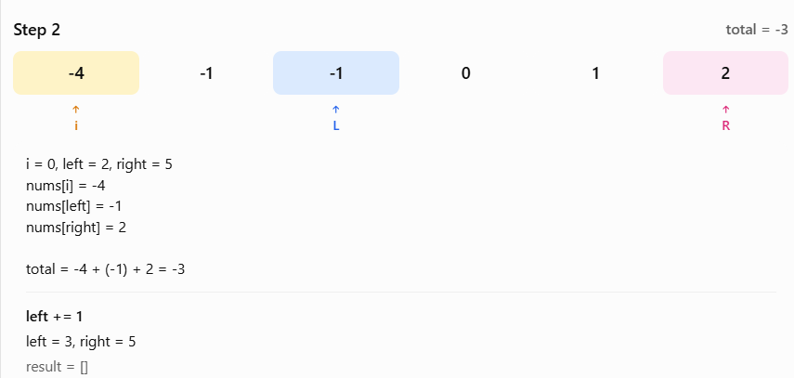
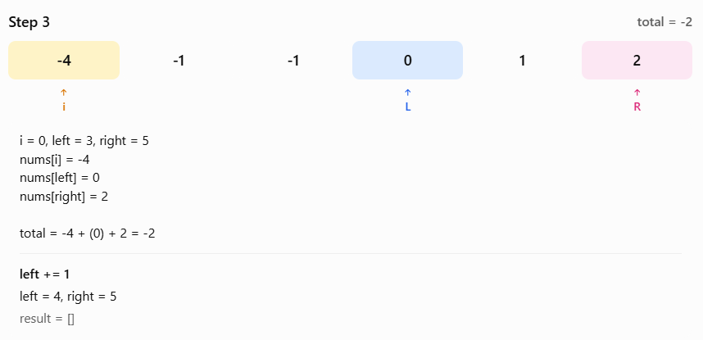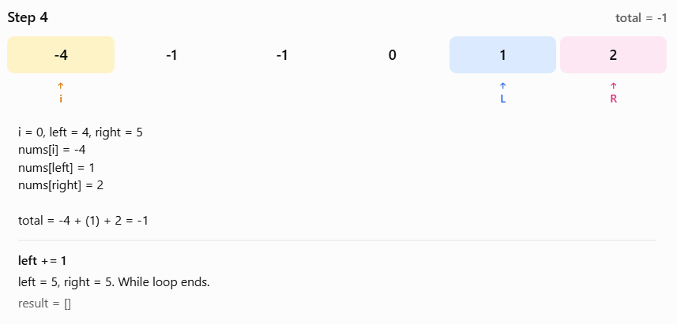
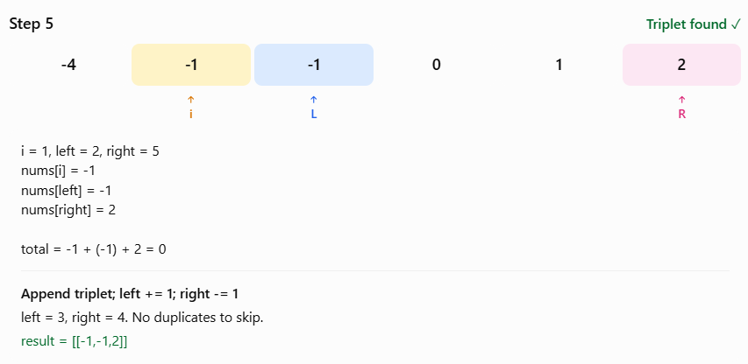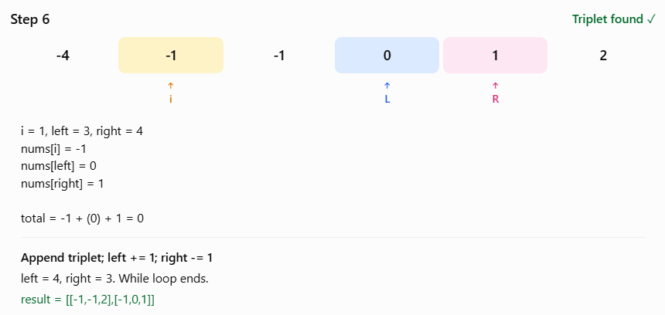
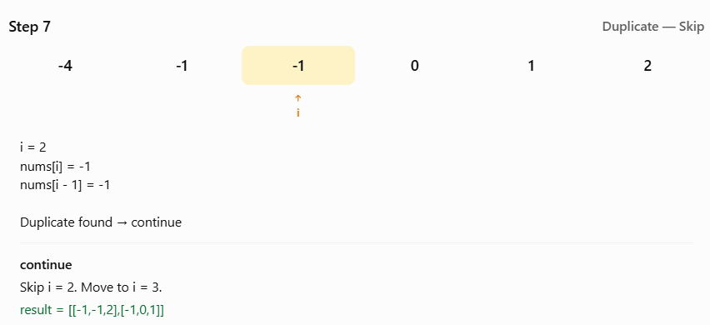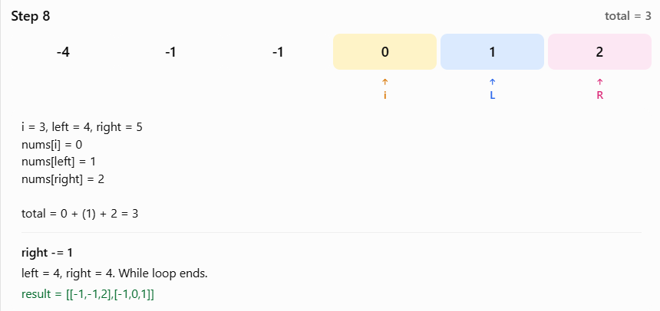

20) Trapping Rain Water (#42)
Given n non-negative integers representing an elevation map where the width of each bar is 1, compute how much water it can trap after raining.
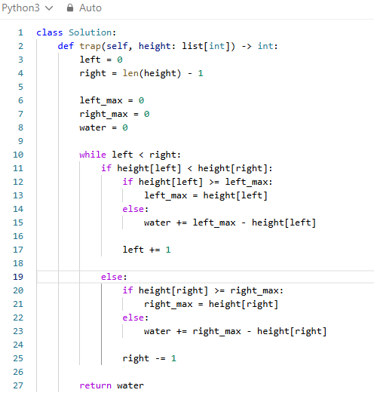
left = 0
- Initializes the left pointer at the first index of the array.
right = len(height) - 1
- Initializes the right pointer at the last index of the array.
- For an array containing 12 elements, right starts at 11.
left_max = 0
- Stores the maximum height encountered while moving the left pointer from left to right.
- Initially, we haven't processed any bars, so it is 0.
right_max = 0
- Stores the maximum height encountered while moving the right pointer from right to left.
- Initially, it is also 0.
water = 0
- Stores the total amount of trapped water calculated so far.
- Whenever we find water above a bar, we add it to this variable.
while left < right:
- Continues processing bars until the two pointers meet.
- We process one bar during each iteration and move one of the pointers inward.
if height[left] < height[right]:
- Checks whether the current left bar is shorter than the current right bar.
- If the left bar is shorter, we process the left side.
- The reason is that the taller right boundary allows us to determine the water on the left using left_max. We do not need to find the complete maximum on the right before processing this bar.
if height[left] >= left_max:
- Checks whether the current left bar is greater than or equal to the tallest bar we have encountered on the left.
- If it is, no water can be trapped above this bar because there is no taller bar on its left.
left_max = height[left]
- Updates the maximum height encountered on the left.
- For example, if left_max = 1 and height[left] = 2, we update left_max to 2.
else:
water += left_max - height[left]
- If the current bar is shorter than left_max, water can be trapped above it.
- We subtract the current bar's height from the maximum height on the left and add the difference to water
- For example:
- left_max = 2
- height[left] = 0
- water += 2 - 0
- This adds 2 units of water.
- Notice that we use += because we want to accumulate the water found at every index, not replace the previous amount.
left += 1
- Moves the left pointer one position to the right because we have finished processing the current left bar.
else:
- This block executes when the right bar is shorter than or equal to the left bar.
- In this case, we process the right side instead.
if height[right] >= right_max:
- Checks whether the current right bar is greater than or equal to the tallest bar we have encountered on the right.
- If it is, no water can be trapped above the current bar.
right_max = height[right]
- Updates the maximum height encountered on the right.
- For example, if right_max = 1 and height[right] = 2, we update right_max to 2.
else:
water += right_max - height[right]
- If the current right bar is shorter than right_max, we calculate how much water can be trapped above it.
- For example:
- right_max = 2
- height[right] = 1
- water += 2 - 1
- This adds 1 unit of water to the accumulated total.
right -= 1
- Moves the right pointer one position to the left because we have finished processing the current right bar.
return water
- Returns the total trapped water after the two pointers meet and the loop finishes.
TRACING
height = [0,1,0,2,1,0,1,3,2,1,2,1]
left = 0
right = 11
left_max = 0
right_max = 0
water = 0


